Sustainable Energy News No. 81, November 2017
Newsletter of INFORSE, International Network for Sustainable Energy
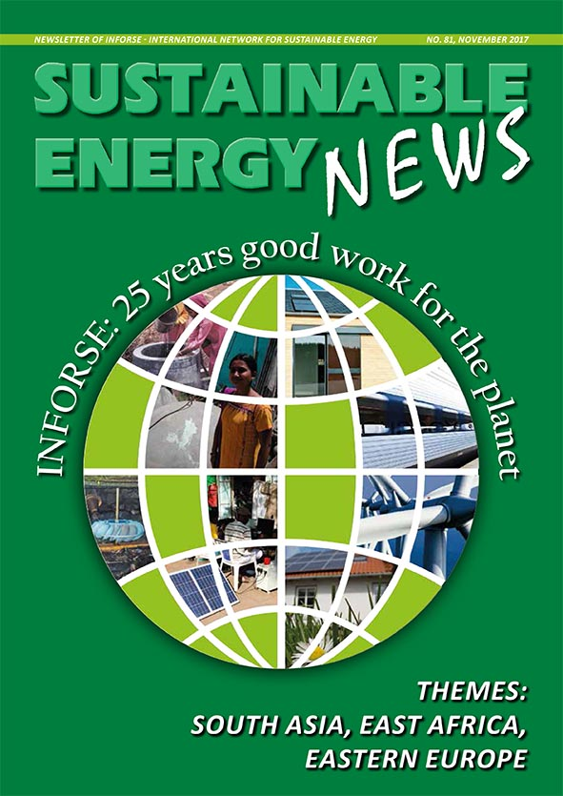
More:
http://www.inforse.org/europe/news-fr.htm

EDITORIAL p. 2
25 Years for Sustainable Energy – and Challenges for the Next 25

CLIMATE COP p. 3
Get Ready to Use the
Paris Agreement
- COP23: First Gender Action Plan of UNFCCC
- INFORSE Joined New 100% RE Platform
- COP23 Side Event

INFORSE 25-YEAR pp. 4-5

THEME: PIPA / EAST AFRICA
pp. 6-8
Promoting Implementation of the Paris Agreement in East Africa:
- Kenya
- Uganda
- Tanzania
THEME: ASET / EASTERN EUROPE pp. 9-11
Sustainable Energy Transition in Eastern Europe:
- Ukraine
- Armenia
- Belarus
- Macedonia
- Serbia

THEME: EVD / SOUTH ASIA
pp. 12-15
Eco-Village Development as Climate Solution in South Asia:
- Bangladesh
- Nepal
- India
- Sri Lanka

BACK PAGE: p. 16
COP23 INFORSE EXHIBITION
COP23 // SIDE EVENT
INFORSE-Suswatch-INSEDA
Date: Thurs., 9 Nov., 2017
Title: Proposing stronger NDCs, LEDS & Paris Rulebook for poverty reduction and local village development

INFORSE: International Network for Sustainable Energy

