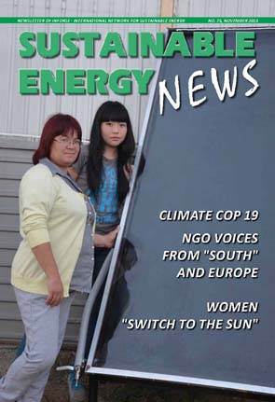
Sustainable Energy News No. 75, November 2013
Newsletter of INFORSE, International Network for Sustainable Energy

Climate COP 19
NGO Voices
Women theme

More:
http://www.inforse.org/europe/news-fr.htm

EDITORIAL p. 2
The Big Issues: Climate & Poverty by Gunnar Boye Olesen

CLIMATE COP p. 3
- Climate COP19 - Time for Common Understanding
- INFORSE-HELIO-AIWC Side Event and Exhibition: 16 November, 2013
- New INFORSE Publication: Combining Energy Access and Climate Protection

WOMEN THEME pp. 4-7
Women at UNFCCC COP19
- Side Events, Gender Day
- Women "Switch to the Sun" in Eastern Europe, (WECF, Ecoclub)
- Innovative Financing Helps Women Solar Entrepreneurs in Kenya, Rwanda, Tanzania (ENERGIA, CARE-USE)
- INFORSE Publication: Gender 2001-2012 (INFORSE) Editor: Judit Szoleczky

SOUTHERN VOICES p. 7
INFORSE in Southern Voices on Climate Change

AFRICA: p. 8
Young Volunteers Active on Energy in Africa

EUROPE: pp. 9-11
INFORSE Calling upon EU:
- INFORSE Europe Push for Climate Targets
- Boilers: EU Ecodesign
- New Danish NGO Strategy
- Publication: Transition Blueprint for Britain
News from Members:
- European Sustainable Energy Award for Prisons
- Campaign against Lignite, Macedonia
- European Community Power Project
INFORSE-Europe General Meeting: 16 Nov. 2013
INFORSE in Belarus
- Study Tours: North & Central Europe /ECSE.
Project by INFORSE, SEA (Sweden) and CES (Belarus).
- Energy Advisory Office Opened in Minsk
ADVICE Project. Project by SEA (Sweden), CES (Belarus), and INFORSE.
- November 11, 2013 - International Day of Energy Saving/SPARE

INFORSE MEMBERS p. 12

