PROCEEDINGS
INFORSE SOUTH ASIA NATIONAL WORKSHOP
and
Capacity Building of Grassroots NGOs in
RETs FOR POVERTY REDUCTION IN INDIA
&
One Day National Seminar on
DECENTRALISED POWER/ ELECTRICITY GENERATION

held at
Om Shanti Retreat Centre, Manesar, Gurgaon, Haryana. India
24th – 26th May, 2007
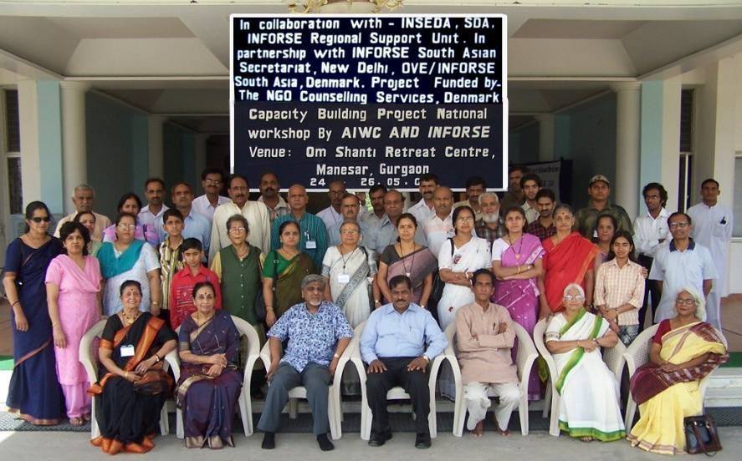

Organised & Conducted Jointly by
AIWC – INSEDA- SDA

In partnership with
INFORSE-SOUTH ASIA & OVE-DIB, DENMARK

Funded by
THE NGO COUNSELLING SERVICES – DENMARK
More information: www.inforse.org/asia or www.inseda.org

CONTENTS

> Acknowledgement

> ORC Campus Visit

> Invocation- lighting the lamp and motivational Speech

> Welcome to the participants and Inaugural Speech

> Introduction of the objectives of the workshop

> Chief Guest’s welcome – introduction – keynote address –I

> Vote of Thanks to the Chief Guest

> Technical Session- I –Choosing Right RET Solutions

> Technical Session –II –Solutions: Sustainable Energy Technology
Group Deliberations

> Technical Session-III- Organisations: Local organisations
Managing sustainable energy

> Keynote address -II – Renewable Energy Technologies for poverty
reduction towards sustainable development
and distance education.

> Technical Session-IV- Financial Manual: Micro-Finance based
sustainable energy solutions for poverty
reduction in India.

> Presentation of workable action plan by the participants

> National Seminar on Decentralised Power/Electricity Generation

> Closing Session – Feedback from participants /suggestions

> Statement by the Participants of the Workshop and Seminar

> Vote of thanks

Preamble and Background Information of the INFORSE National Workshop and the National Seminar

All the invited participants were sent the information and relevant details in advance so that they could come prepared to effectively participate in the proposed participatory two days INFORSE national workshop of NGOs trainers on “Capacity Building of NGOs in RETs for Sustainable Energy Solutions to Reduce Poverty in India”, and to be followed by one-day national INFORSE Seminar of NGOs on the “Decentralized Electricity/Power Generation”. Both these two events were planned to be held at the Om Shanti Retreat Centre, run by Brahma Kumaris, Manesar, Gurgaon from 24-26 May, 2007. The venue is 1½ hour by road from Delhi on Delhi-Jaipur high way.
These two events (total three days) were organized jointly by AIWC, INSEDA and SDA in partnership with INFORSE South Asia regional support unit (RSU). Since the invited NGOs were members of either one or more of the four of these four partner organisations, the following background and brief information of each of these organizing partners were also sent to the invitees:
AIWC is one of the oldest & pioneering organizations working for the development & empowerment of women. With more than quarter million members and five hundred branches all over the country, AIWC has been working in the propagation of Renewable Energy Technologies especially for women for more than three decades. Identified as the Nodal Agency by the MNES (Now MNRE) AIWC has implemented various programs like Improved Chulha, Biogas, Solar Thermal and Solar P.V. Programs – Solar Lantern-Home light system etc).
INSEDA (Integrated Sustainable Energy and Ecological Development Association) is the national India organization formed by the grassroots NGOs who had been involved in the promotion of renewable energy programmes with special focus on the implementation of biogas development and renewable energy technologies in rural areas of the country, since 1980. INSEDA is a membership organization, at present having about 50 Indian NGOs as its members. The member organizations had been operating as an informal network for more than 15 years before establishing INSEDA as a formal body. INSEDA was registered as a society on December 11, 1995.
SDA (Sustainable Development Agency) is the association of over 30 grassroots NGOs from 5 states of South India, and their members have been implementing biogas plants under the Aegis of MNES (Now MNRE), Government of India for over decades. SDA is also one of the members of INSEDA as well as INFORSE.
INFORSE (International Network for Sustainable Energy) was founded by NGOs involved in the promotion of Sustainable Energy in 1992 at the Global Forum of NGOs of the United Nation’s Earth Submit held in June 1992 at Rio De Janerio, Brazil. The vision of INFORSE is based on renewable technologies including solar, wind, biomass, biogas and micro-hydro. At present it has more than 150 members of which over 20 are in South Asia. INFORSE South Asia is a regional network of independent non-governmental organizations that encourage the growth of sustainable energy solutions in order to reduce poverty and protect environment.
The INSEDA is hosting the INFORSE South Asia since December 1995, and the Secretary General-Chief Executive of INSEDA is the INFORSE Regional Coordinator for South Asia.
All India Women’s Conference (AIWC) which is the National Focal Point for India (Gender) is actively involved with the activities of INFORSE right from the beginning. AIWC is one of the key project partners of INFORSE SA capacity building for NGOs in SETs.
SDA is the National Focal Point for India (General) since 2004 and one of the members of INSEDA and INFORSE.
INSEDA, AIWC and SDA are the project partners of INFORSE SA capacity building for NGOs for Sustainable Energy Solutions (SES) for poverty reduction in South Asia.
The invited organisations were also informed that these two events will be two distinct events, but since the NGO invitees were common to both, to save in time of travel and logistic and costs as well as for the sake convenience were organized one after another. The invitee organisations were also informed that the participatory national workshop to be held on the first two days will be devoted exclusively for discussing the two manuals {namely, the Sustainable Energy Technical (SET) and the Finance Manual}, prepared by the INFORSE Capacity Building project partners from South Asia along with the two partners from Denmark. The third and last day will be devoted (with two main sessions) exclusively for the Decentralized Generation of Power/Electricity.
The dates of these two separate events would be as follows- (1) INFORSE Capacity Building Project National Workshop of NGOs in RETs on May 24 and 25, 2007; and (2) Decentralized Generation of Power/Electricity on May 26, 2007

INFORSE Capacity Building Workshop of NGOs in RETs on May 24 & 25, 2007
Aim and Methodology of the Workshop on Capacity Building
The aim of the workshop was to discuss threadbare, the following two NGO trainers’ manuals:
- Manual on Renewable Energy Technologies for Sustainable Energy solutions to reduce Poverty in South Asia.
- Financial Manual on Sustainable Energy solutions for Poverty Reduction in South Asia.
Methodology of the National Workshop:
The national workshop was planned to be conducted in a participatory mode to ensure maximum participation of the representatives of all the NGOs. This was proposed to be achieved by the formation of three break-up or working groups soon after the inaugural and plenary sessions. The Group Discussions- in three break-up groups would come up with the important points related to the two manuals and how to use them effectively as the manuals to train the NGO trainers as well as the grassroots developmental NGOs involved in the promotion and implementation of renewable energy technologies (RETs). The three break-up groups would also use these two manuals as resource materials for the discussions. In addition to discuss the practical problems and issues related to the energy access, and how the sustainable energy solutions the different local organisational solutions incorporated under chapter-4 of the SET manual would be relevant to their local situation, and how they as a group would utilize these solutions for poverty reduction. Each break-up group would present their respective suggestions and recommendations to the in the plenary sessions for discussions, clarification and finalisation of consensus recommendations as well as an NGO statement.
Follow-up Programme and National Action Plan:
These three break-up groups of participants would also prepare a tentative ‘Follow-up programme’ of the national workshop to be taken up during the next 6-months as the part of the INFORSE Capacity Building project, as the last activity before its is formally completed. The small break-up groups will also prepare a tentative ‘Action Plan’ in the first two days, which would be compiled and presented at the end of the third and last day in the plenary session of the national seminar on the Decentralized Electricity/Power Generation, and a final draft ‘Action Plan for India’ will be prepared and endorsed in principle by the participants, to be implemented as a long term programme by NGO, beyond the present project period which will be formally completed in December 31, 2007.
The follow-up programme has to be taken up by the two national focal points for India, namely AIWC and SDA in partnership with INSEDA and the INFORSE Regional Support Unit, which is proposed to be completed by October 2007, after which the INFORSE Capacity building project completion has to be prepared by AIWC and SDA, in which active support and guidance will be provided by INSEDA and the INFORSE Regional Support Unit (RSU) secretariat.
Later on, using this ‘Action Plan for India’ also with inputs received from other project partners from the three countries ((i.e. draft national ‘Action Plan of NGOs for Bangladesh, Nepal and Sri Lanka’), the INSEDA, INFORSE–South Asia and the INFORSE International will prepare a draft “Regional Action Plan (RAP) for South Asia”, for the next three years period. This (RAP-2008-10) will be shared with all the national focal points from the four countries (Bangladesh, India, Nepal and Sri Lanka) to get their feed-back and inputs before it is finalized and used for the preparation of future project for INFORSE South Asian Region.

Seminar on Decentralized Generation of Power/Electricity on May 26, 2007
The next day (third and last day) after the conclusion of the two-day workshop, AIWC and INSEDA in partnership with the INFORSE-South Asia and SDA, was planned for organizing a one day national NGO seminar on ‘Decentralized Electricity/Power Generation’. Thus the third day was devoted exclusively for the Decentralized Electricity/Power Generation, through two main sessions in the forenoon of 26th May where eminent experts from the field with experience in one or more aspects related to planning, designing, implementing and operating of such systems; as well as representatives of project funding and monitoring in India, were invited to present their experience as well as participate in the interactive session with the participants.

In the concluding session, (afternoon of 26th May) the draft action plans prepared on the 24th & 25th was discussed and final draft was inputs from all the participants during the plenary session. Later on this will be sent as a part of the reports/proceedings of the national workshop and seminar to all the invited participants and others to get their feed back and further inputs, if any, before finalizing it as an ‘INFORSE Action Plan of NGOs for India” for the next three years- i.e. 2008-2010. It is expected that the Partner NGOs {with the assistance and guidance from INSEDA, AIWC, SDA and the INFORSE Regional Support Unit (RSU) Secretariat (based in Delhi)} will undertake implementation of Sustainable Energy (SE) based activities (or integrate it with their on-going and new projects) for the reduction of poverty, as per the ‘INFORSE Action Plan of NGOs for India’ in their respective area of operation (with appropriate modifications to meet their particular requirements) beyond the present INFORSE South Asian capacity building project period, ending on December 31, 2007.

OSRC Campus visit to see the Solar Energy based systems
A site visit for the participants to the OSRC campus was organized prior to main session on the 24th May, 2007.
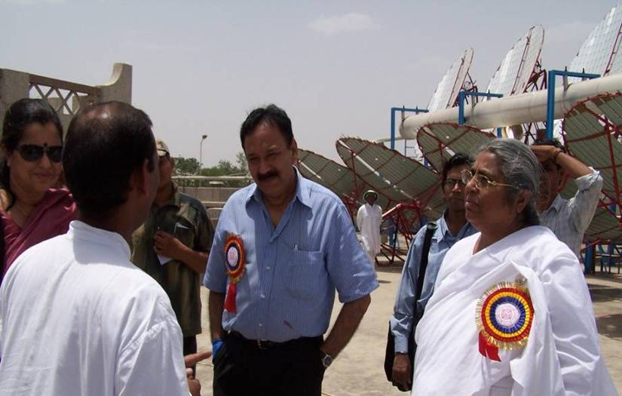
The venue of this participatory training programme is a standing example where various renewable energy sources are being fully utilized. Different Solar Energy Solutions have been put to practice within the premises viz., Solar Steam Cooking System, 200 kW stand alone solar power plant and RO system for treatment of drinking water.
ORC stands as one such institutional example where RETs practical solutions are on demonstration and under daily large scale use. OSRC passionately promotes the RETs.
- Roti making section: Atta/ flour kneading machine was explained. 20 kg kneaded in 10 minutes.
- LPG powered frying pans: steel plates of area 1x1.5 sqm with chimney having ideal combustion of fuel capable of making 2000 chapattis per day.
- Kerosene powered stoves to cater to cooking for 150 - 200 people were explained.
- 5 drums having steam at 8 kg/sqm connection for cooking was explained. These were of around 150 kg per litre capacity.
- Kerosene bhatti for deep frying work were explained.
- Vegetable cutting, potato peeling section was explained(5 kg in 3 minutes)
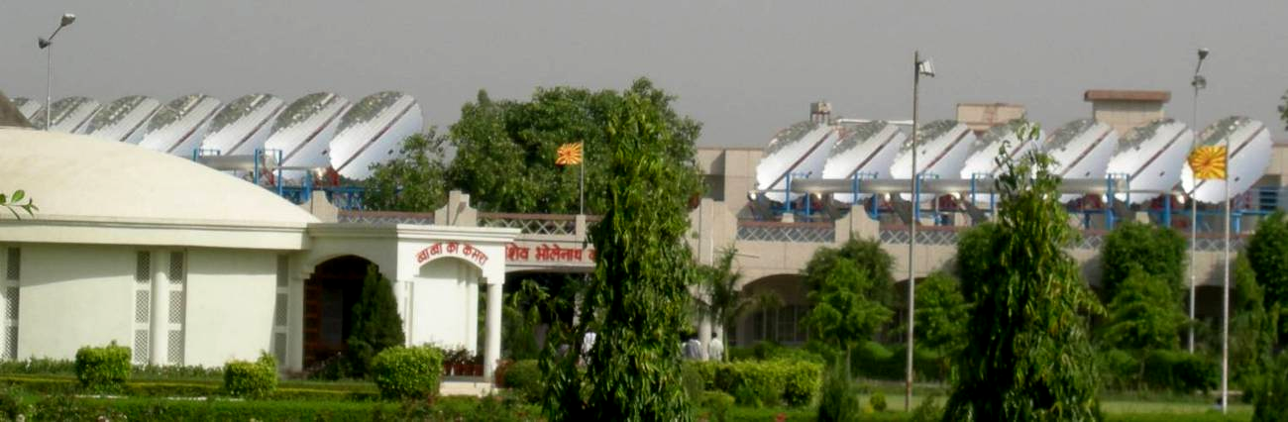
- All the vegetable and other waste arising out of the kitchen operation is taken for onsite composting to convert into compost/ manure & used as fertilizer.
- Solar thermal by parabolic reflector: Each parabolic reflector is of 9.5 sqm generating up to 5000 watts. These raise water to steam at 8 kg/sqm pressure and 300 degrees Celsius temperature. This steam is used in cooking drums. Each reflector has a receiver/ concentrator. Water is lead inside the reflector and this water gains heat to be converted to steam at 350 degrees Celsius. There is an automatic tracking system for solar rays- directional integration is being done automatically. This system caters to cooking for 5000 people which is widely used by the centre, during large scale training programmes conducted by them.
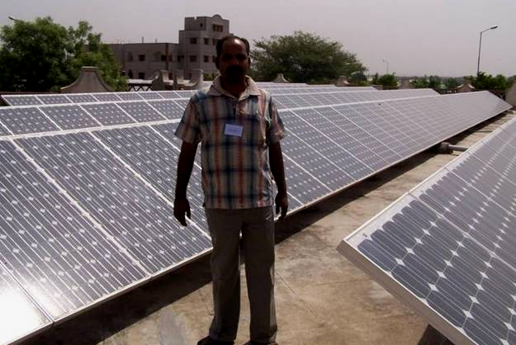
- A diesel fired backup boiler is in use parallel to the steam powered boiling system.
- Solar PV system was seen of 200 KW, spread on an area of 2000 sqm, which cater to almost all the requirements on campus – both for lighting and cooling.
- Waste water produced in the campus is processed & used for horticulture (irrigating flower gardens).
All the participants keenly went through all the energy efficient and energy saving devices and raised a lot of queries which were answered by the voluntary workers from all over India and abroad who are all highly qualified and professionals who are devoted to their work.
One of the main reasons for the success of these solar energy based working systems are due to the devoted and regular service put in by 150 (Brahma Kumaris and Kumars) who are all highly educated and committed since they are all practicing the principles of this great institution whose members have got correct mixture of spirituality and science.

DAY ONE- 24th MAY- 2007
Welcome
Mrs. Suguna Swaminathan, Manager HR, BHEL & Jt. Secretary, Women in Public Sector extended a very warm welcome to the participants and particularly to Dr. Ms. B. K. Asha, Director, ORC. She briefly stated the significance of this workshop on capacity building of grass root NGOs in Renewable Energy Technologies for poverty reduction in India in today’s energy environment. Energy is the important element in our daily schedule–consumption-production–delivery. It can’t be substituted but the source can be. Therefore, it is all the more crucial to have such capacity building workshops only to vigorously promote the affordable RETs in making the maximum use of natural resources of alternative energy.
Address by Dr. Ms. B.K. Asha, Director, OSRC, Manesar
She chose the right topic of “stress’’ to address the participants right at the start of the meetings representing number of NGOs and social workers from various states. In her unique way she made it plain that in human existence stress is the portion and emphasized to deal with stress with positive attitude. Dr. Asha shared with the participants some key factors to deal with this critical issue.
- Stress doesn’t lie outside; it is our attitude towards it. Positive thinking and attitude is the key.
- People change, situation change, but do we also change along with them? Keep challenging your assumptions.
- Don’t allow yourself to get conditioned. Sometimes we associated certain things to memory. Observe traffic control of thoughts. There is a continuous flow of positive, negative, necessary and waste thoughts. Research says maximum number of thoughts that arises in our mind is waste and aimlessly uses our precious energy.
- Say no to negativity, waste, adopt filtering of the thoughts
- Music is a nice way to rejuvenate, a flow of thoughts.
- Earn the blessing of people around you.
- Maintain an attitude of detached involvement.
- Give attention to necessity, if encounter a problem, withdraw, empower yourself and then come back
- Transfer your stress to open skies, oceans. Enjoy broadness and vastness of these.
- Meditate to heal, heal the wounds of the soul. Treat mind like a baby. Don’t curse it
- Find time for yourself. Be yourself
The participants found this to be of immense help in their daily chores.

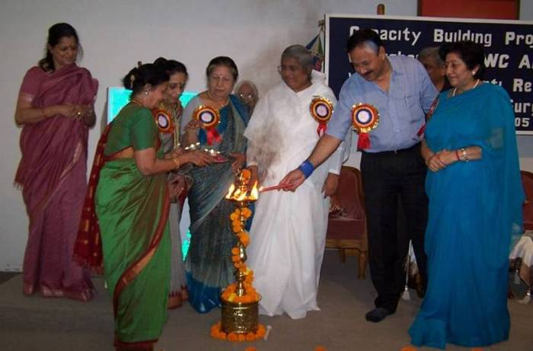
Inaugural Session
The workshop was formally opened by lighting the lamp by the Chief Guest Mr. V. Subramaniam, Secretary, MNRE-GOI, Dr. Ms. B.K. Asha, Director, ORC, Dr. Mrs. Manorama Bawa, President, AIWC, Mr. Raymond Myles, Secretary-General-cum-Chief Executive Officer, INSEDA & Coordinator INFORSE Asia.
Dr. Bawa in her inaugural speech welcomed the Chief Guest – Mr. Subramaniam, Dr. Asha, Mr. Raymond Myles, the office bearers of AIWC and the participants to this special workshop being conducted under these serene surroundings, so generously provided by Dr. Asha at ORC for which AIWC was grateful.
In her brief speech she enumerated the wide range of socio-economic sustainable endeavours that AIWC has initiated primarily focusing on marginalized communities and more so women being the primary partners in development initiatives. AIWC continues to strive to reach out to the un-reached strata of the societies through its countrywide network of 500 branches.
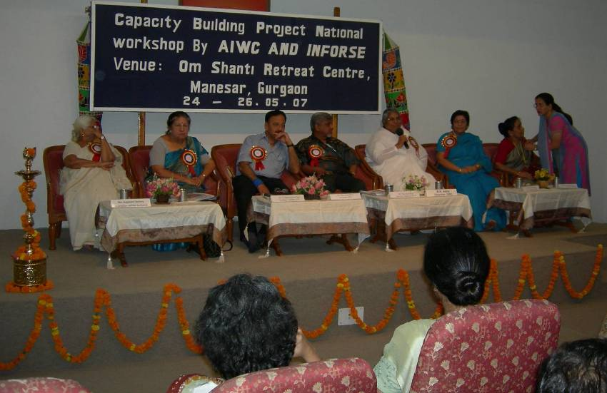
She stated that AIWC over the years of deeper involvement in the lives of people to whom the support matters, has been constantly searching for new ways in engaging women for their betterment. One of the significant areas is Alternative Sources for Rural Energy i.e. bio-gas, solar energy-use, solar energy based production, trainings etc. It has earned AIWC a name for itself and we continue to treat this element in our programmes on a higher priority and thereby create avenues of sustained family income. MNRE and other GOI ministries and officials have always extended a generous support to AIWC. AIWC attaches importance to such people based and technology-oriented workshops to both share our experience and equip us with new and affordable technologies. She once again welcomed all the honorable guests and the participants representing Haryana, Rajasthan, Bihar, Jharkhand, Tamil Nadu, Jammu & Kashmir, Kerala, Delhi, Maharashtra, Uttar Pradesh to this workshop and wished it all success.

Introduction of the Chief Guest – Mr. V. Subramaniam, Secretary-MNRE-GoI

Mrs. Lalita Balakrishnan, Director Workshop said that we were delighted to have with us Mr. Subramaniam, presently, Secretary, MNRE-GOI, he has been associated with many Rural Development programmes introduced by the GOI and is well versed with conditions–problems and the needs of people in rural areas. He had been more than kind for sparing his valuable time to come all the way from Delhi to inaugurate this National Workshop and address us. This indicates his genuine interest in such endeavours. One of the areas that he was passionate about is RETs, for which he extends all the support that GOI offers.

Inaugural Address
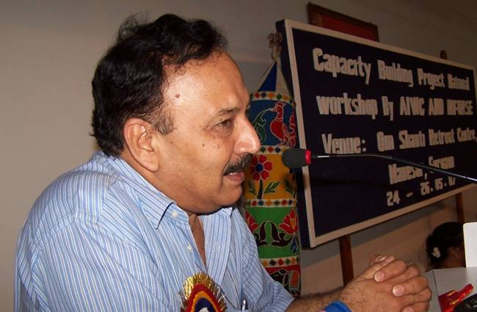
Mr. V. Subramaniam in his inaugural address dealt at length the significance-practicality and abundant availability of the natural resources. He talked about the new source of bio-fuel and mentioned the ways of utilizing the same sources of energy more efficiently. Sun-viable options for the future would have an actual capacity utilization of power only 40% and it was necessary to store energy produced during the day in batteries and utilize it during night. In his rich experience he felt it was important to make people understand the usefulness and importance of Renewable Energy Sources and work towards it for achievement – not in quantity, but in quality. There are good number of examples where non-conventional energy sources have been put to effective and successful use, such as Smokeless villages near Tirupati where Solar cookers- Solar water heater- Solar panels etc. have been used successfully.

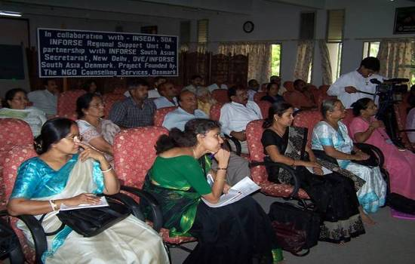
He also explained the schemes that were under his Ministry to solely promote the RET’s for the benefit of all and more so for the poor using the network of NGO’s. He also shared the reasons with the participants for changing his ministry’s name from MNES to MNRE (Ministry of New & Renewable Energy – which is more positive). He promised to have training programmes for the youth especially from rural areas.

Presentation by Mr. Raymond Myles, Regional Coordinator, INFORSE South Asian Region and Secretary General, INSEDA

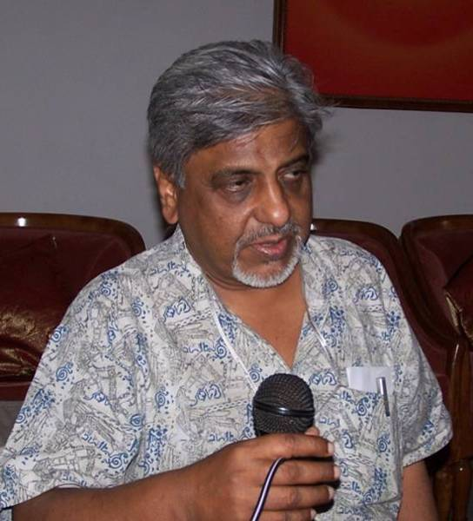
Mr. Myles briefly up-dated the participants on the history and role of INFORSE & INSEDA
- INSEDA members were operating as grassroots NGOs, an informal Network involved in promotion and implementation of RET’s since the year 1980 and primarily in Biogas Development Programme. They established INSEDA as a formal national body in October/November 1995, which was subsequently registered as an association on December 11, 2007 under the Indian Societies registration Act-XXI. INSEDA members is country wide, therefore ensures wider participation and representing variety of cultures-traditions.
- INFORSE came into being in June,1992 at the time of Global Forum of NGOs held in Rio de Janeiro.
- INFORSE launched a Capacity Building Project of NGO for Poverty Reduction using Sustainable Energy Solutions, in four South Asia Region countries, consisting Bangladesh, India, Nepal and Sri Lanka. This programme has been launched in the following seven phases involving number of NGO’s
- Phase One - Collection of literature, documents/manuals
- Phase Two - Preparation of Energy Status Report
- Phase Three - Detailed House Survey
- Phase Four - Preparation of SET & Financial Manual on RETs of PR
- Phase Five - Organisation of National workshops and seminars
- Phase Six - Preparation of NGO action plan for undertaking projects beyond the present project period
- Phase Seven - Follow-up:
a). With the NGOs who participated in the national Workshop and Seminar, to see that they are implemented the learning from these two as well as the SET and Financial manual in their own situation;
b). Provide guidance and linkages for developing proposals and approaching appropriate funding/financing agencies for getting possible support for their SET and energy conservation based activities/project;
c). With government, policy & decision makers to share the two manuals so that they can incorporate capacity building and projects related to Sets in their appropriate policy documents;
d). With universities and educational institutions to incorporate SETs as a part of their training activities as well as associate NGOs as resource persons in conducting such programmes; and
e). Facilitate participation of NGOs in workshops/conferences organise by the corporate sectors, other donors and different ministries of Govt of India.

He stated that NGO’s have learnt from practical implementation in their respective areas of operation that though a technology may be size neutral BUT was neither gender neutral nor socio-cultural neutral nor resource neutral.
Mr. Myles stressed the need to not only teach the partners and people especially the poor, but ensure that once trained they also have right to use the technology for their benefit towards this end, it was our duty to work and actively promote the RET’s in a comprehensive manner. He therefore, proposed the following steps:
- Capacity building of the different stakeholders
- Undertake appropriate project/programme to enhance their income and generate employment as well
- To make resources available to the poor using micro-financing to finance the RET’s. This does not create additional pressure on their finances and can repay in an easy manner.
- Promotion of Self-Help-Group, Micro-Financing, involvement of private sector, Micro utilities, Micro entrepreneurs etc.
Mr. Myles further explained some of the important activities carried out by various key partners of the projects as well as broad topics covered in manuals and the proposed CDs, to be brought out before the close of this project are:
- Improved cooking stoves
- Use of bio-gas for cooking and lighting
- Biomass based decentralised energy programme
- Collection of regional data
- SET Manual - Discusses some affordable RET solutions /choices and value of choosing the Right RET solution on regional level
- Financial Manual – Describes various financial options in promoting RET’s
- CD will include all these manuals and translations of SET manuals in four languages (Bengali, Hindi, Nepali and Singhalese) and case studies/good practices and many other useful manuals and information and other relevant materials etc.
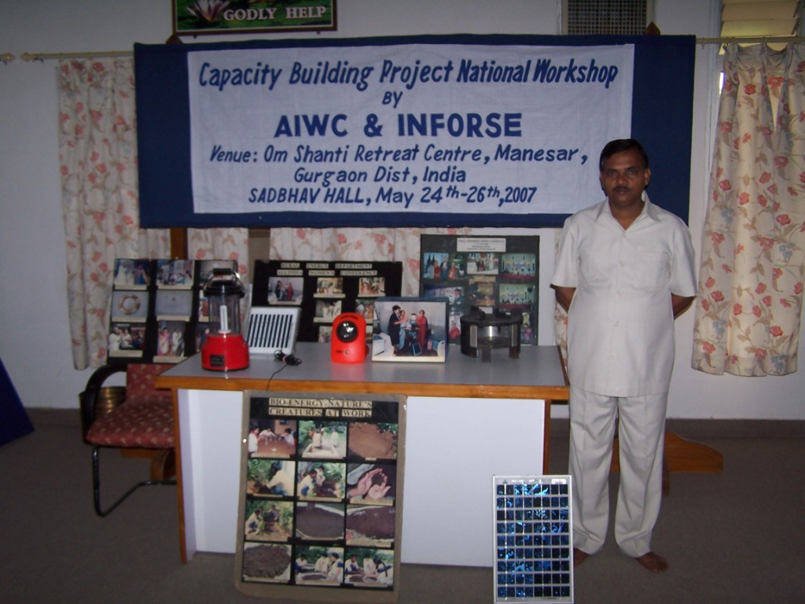
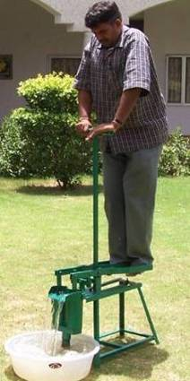
Mr. Myles at this point of time presented copies of two INFORSE manuals namely (i) SET Manual and (ii) Financial Manual to Mr. V. Subramaniam, Secretary, MNRE-GOI.
He briefly mentioned about some of the other of RET’s covered in the manual-they are:
- Anagi cooking stove in Sri Lanka;
- Improved cook stove in India;
- Cooking with briquettes-cum-waste in Nepal;
- Animate Energy, like treadle pump for irrigation of very small land holdings;
- Solar PV pumping set for irrigation of agricultural fields;
- Grameen Bandhu Biogas plants-Bamboo based- Rajasthan, India (different stages including weaving bamboo nets were briefly explained);
- Solar cookers, Solar Dryers, Solar lanterns propagated by AIWC and other focal points;
- Solar PV operated decentralized water purification unit for round the clock drinking water supply in non-electrified and uncertain power supply villages;
- Promotion of Jatropha cultivation–promoted by WAFD and INSEDA utilizing panchayat /waste /unused portion of lands and bunds/ boundaries of fields on a co-operative as well as on individual basis involving village youth /women;
- Operation of dual fuel engine on biogas” generating electricity in mechanical operation” in a village in Rajasthan;
- Biomass Gasifier;
- Wind Energy Generator;
- Community and family-size biogas plant; and
- Utilization of chicken (poultry litter) waste in Biogas Plant in Chunar, Mirzapur, where AIWC had promoted biogas programme in a big way. The bio gas is used by one of the members of AIWC for cooking purposes, not only in her own house but also supported through pipeline to seven houses nearby who pay for their gas supplied by the owner of the Biogas plant.
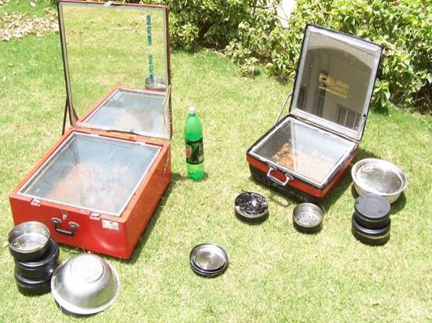
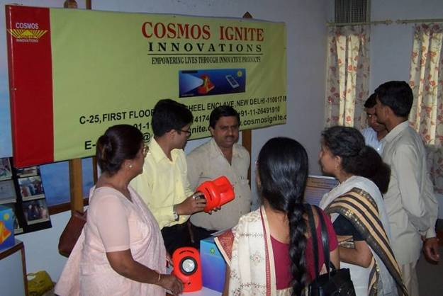

Ms. Rachna, a student participant from Delhi College of Engineering raised the question “Why don’t we talk about renewable sources of energy being used in urban areas? What studies were done before putting “Timarpur Biogas Plant” in operation that it had to be shut down within 21 days of its operation?
The Chief Guest explained. There was no caste distinction for using the energy and it can be used for both rural and urban areas, but storage of energy is very costly due to high cost of batteries which limits the feasibility of the plant.
About Timarpur, he said that we have learnt how not to do a project. It was a case of “committing a mistake and learning from that mistake”.
Secretary MNRE agreed in principle to conduct RETs training programmes for young people. He said more research has to be undertaken to bring down the cost of PV Cells and batteries. He also mentioned the installation cost is high and there is the need to have proper data to check the entire cost effectiveness of any Renewable Energy Systems.

RETs Promoted by TIDE, Bangalore- Ms. Swati Bhogale
Mrs. Balakrishnan introduced Ms. Bhogle to the participants. A graduate in Chemical Engineering from IIT Bombay, she has been intensively involved in searching for new practical-affordable means an d ways to promote RET’s as the member of the dedicated team of TIDE – link organization between rural population and scientific community she was involved with the up gradation of 14 Industrial Sectors which included Biomass fuel efficient stoves, drying applications, kiln sector – pottery lime brick etc.
She emphasized that technology has to be gender sensitive. Pottery kiln designed had to be modified accordingly. Stoves for rubber band making were designed. Major success in innovation used by them (TIDE) is in use in the entire rubber-band industry sector, by utilizing fuel efficient technology.
The herbal /ayurvedic medicine sector in Kerala were studied by TIDE and they were advised not to use LPG. It was substituted by firewood. They also designed fuel efficient smokeless chulhas which are in operation.

In addition to above, some of the other areas of TIDE work are given as under:
- Three entrepreneurs in Kerala were involved in this project and have become successful entrepreneurs.
- Stoves & Coconut driers were improved.
- A self help group (SHG) raised their income to Rs. 2 lakh (INR 200,000)/year and were supported till they doubled their income.
- Supari (Araca nut) boiling sector in Karnataka state was improved.
- Silk reeling sector in Karnataka state was improved.
- Textile Dyers Sector in Tamil Nadu state was advised for improvement in efficiency.
- Industry clusters in three South Indian states were advised on pollution and impacts.

No Micro Credit was available for the women’s enterprise involving Fish drying on sea shore. It was noted to be very unhygienic and the fisher-folk were not getting enough price. The fishermen resorted to biomass dried fish. Marketing network was also established with TIDE’s initiative.
Dung based biogas plants were developed and also used. Also leaf litter based, municipal waste, Kitchen waste based, Coffee waste/high BOD effluent based biogas plants were developed.
70% diesel was replaced with Biogas.
Biogas used in campus replaced 70% diesel.
Ms. Swati offered TIDE assistance to NGOs in capacity building for promoting RETs.
Mrs. Balakrishnan thanked Ms. Swati Bhogle for her presentation which will be a great benefit the participants and also for agreeing to address the workshop at a very short notice.

Post Lunch Session

Presentation on village house hold survey and using the data for sustainable energy based planning, implementtion and community asset management

In the post lunch session the presentation were made by Mr. Ajit Seshadri and his team of engineering students on the household survey data of AIWC adopted village in Haryana state. This survey was gone as a part of the INFORSE-SA Capacity Building project, in which computer data base of the entire village house-hold (conducted by three of INSEDA partners, namely, AIWC, WAFD and SDA) was created by INSEDA using the Microsoft Access. The data was used as an example to show as to how the NGOs can utilise such information for the preparation of realistic plan for sustainable energy based planning, implementation and community asset management. An exercise was done to make the participants aware of doing the relevant survey on energy data.
The facilitators for the session were Mr. Raymond Myles, who gave further details and practical tips to conduct house-hold survey for the collection of comprehensive data using detail format in MS Excel developed by INSEDA. He also explained briefly how to use the data and information to calculate the present energy utilisation in a given village, based on the detail survey, and how to plan for the future energy needs of that village to meet all its requirements in a sustainable manner.

Group Discussions- in three break-up groups

Three groups were formed with specific tasks /topics and then to make a brief presentation.
Krishak Bandhu (KB) Group:
The KB group was given the responsibility to discuss the following technologies from the SET manual:
- Solar Technology, solar photovoltaic cells, solar dryer, solar lantern.
Grameen Bandhu (GB) Group:
The GB group was given the responsibility to discuss the following technologies from the SET manual:
- Smokeless stoves, solar passive heating and cooling, briquettes
Eco-friendly (KF) Group:
The KF group was given the responsibility to discuss the following technologies from the SET manual:
- Eco-friendly group: Biogas, Bio-fuels

The three groups (Krishak Bandhu-KB, Grameen Bandhu-GB and Eco-friendly) came up with the issues and points during the presentations, which they presented to the entire group in the plenary sessions for discussions and finalisation.

DAY TWO- 25TH MAY, 2007

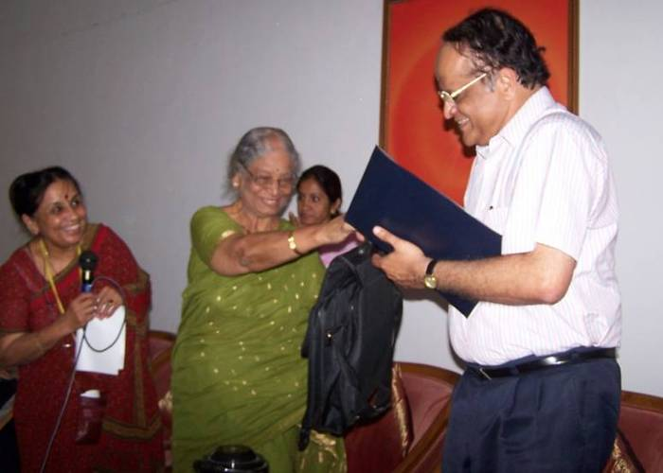
Dr. V. N. Rajasekharan, Vice-Chancellor, IGNOU, Delhi was the chief guest. Dr. Mrs. Jaya Kothai Pillai, the Secretary General, AIWC in her welcome address said that Dr. V.N. Rajasekharan was an acknowledged educationist in our country whose presence was a great privilege to us and said that he had been on various important posts like Vice chancellor, U.G.C.; Director NAAC, Bangalore; Vice Chancellor of many Universities, Guest faculty of many Universities, Fellow of Indian Academy of Science.

Introduction to INFORSE
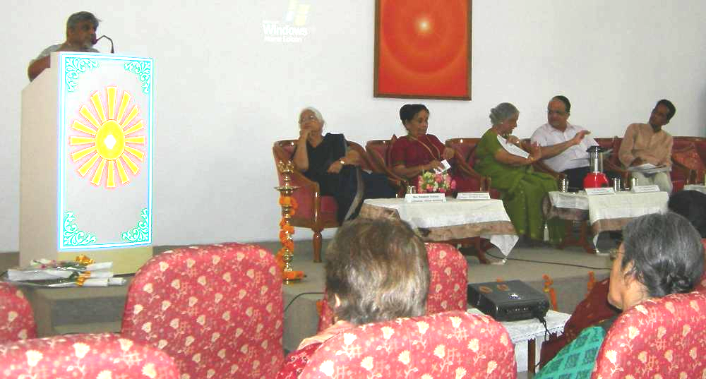
Mr. Myles gave a brief introduction of the INFORSE programs including the printing of two separate manuals; namely a) SET Manual and b) Financial Manual. He mentioned that INFORSE started distance education programme through internet in 2002. This was developed by an international team of which he was a member. He mentioned that he had also developed a module on Biomass technology/bioenergy for distance education programme of IGNOU. He briefed about the follow-up action plan, the intended statement of the NGO’s present to be released in the end of this workshop and the future action plan of INFORSE. Mr. Myles presented two copies of SET Manual and Financial Manual brought out by INFORSE in co-operation with INFORSE partners from Sri Lanka, Nepal, Bangladesh and India.

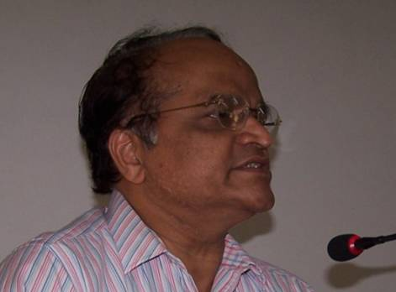
Key-Note Address
Addressing the gathering, Dr. V.N.R. Pillai said that at the very out-set he was happy to be a part of such a gathering since the theme being discussed was very significant in today’s scenario. Following were the key points of his speech:
- Indira Gandhi National Open University-IGNOU has started a Chair on sustainable development.
- Since collaboration & linkage of IGNOU with self help groups and non educational institutes was very important, it caters to about 50 lacs (5 million) students. IGNOU has around 1,700 centers all over the world.
- Another centre for energy studies especially rural areas and women’s contribution to energy generation is in the planning stage. Sustainable energy solution needs to be found. Prime areas of concern include poverty reduction and skill upgradation. In XIth plan of the Govt of India, school of gender studies and development was to come up within IGNOU. He emphasized the need for having the skill building institutions to be autonomous and discussed as to how the capabilities of IGNOU can be shared as well as, how to utilize the expertise of institutions like AIWC.-INSEDA-INFORSE and SDA and their NGO members in the various activities and programmes of IGNOU.
- He said there was greater need to increase the national productivity. In this connection, he talked about a programme to be launched by IGNOU for the capacity building in the next five year plan. He mentioned that only the 5% of the work-force had certified skill in India as compared to 80% in Vietnam. He said that positive and sustainable growth can happen only by making available energy and electrical power to each and everyone.
He also mentioned about the founding of a National Virtual Academy by Dr. M S Swaminathan which has involvement with the common people in the true sense. He talked about the real knowledge and skill lying within the common man and said that we should identify the skills and work upon them. He strongly supported the rural knowledge and connectivity and said that for its utilization their needs to be proper interaction between the user and the resource. Skill training establishments should carry on these capacity building programmes and their humble expertise should be availed to invite eminent personalities from educational institutions so as to build up a proper connectivity
He talked about a certificate course in sustainable development carried out by IGNOU and a full time Chair is to be established. He emphasized on the role of women in sustainable development. He suggested identifying members to form a core group from national organizations i.e. AIWC- INSEDA-SDA-INFORSE and other such organizations to meet Dr. Swaminathan, the founder of the national virtual academy and take up programmes.
He also invited AIWC, INSEDA, SDA, INFORSE to establish institutional collaboration with IGNOU and urged these institutions to develop and give an action plan as soon as possible for the collaboration to come into effect. This was highly appreciated by all the representatives of the said organizations. He said he was convinced that together with our accumulated knowledge and experience greater practical results could be reached. Therefore, it was essential to have a serious dialogue with these agencies. He generously offered to sponsor such workshops for them and their member NGOs in future. He also suggested having a joint meeting of the NGOs present and IGNOU in July-August 2007 to discuss further opportunities to promote RETs and IGNOU would be happy to host such a gathering.

Vote of Thanks to Dr. Rajasekharan Pillai:
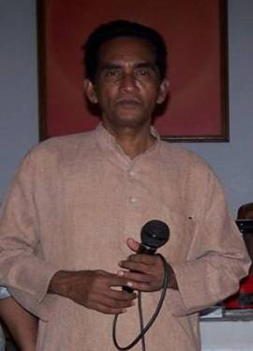
Father Mathews, INFORSE National Focal Point (General), proposed a vote of thanks to Dr. Pillai for delivering his keynote address on a topic so relevant to our times and particularly speaking strongly in favour developing gainful skills to reach the poor and spelt various ways to extend the sustainability of technologies and sharply focusing on RET’s. He thanked the Chief Guest for sparing his valuable time to talk to the participants.
Fr. Matthew said that the NGOs were doing good job but were not getting the required support from the government. It seems that Govt. of India was not interested in sustainable development projects now. It was not giving any consideration to the biogas programme, which could help in the development of not just rural areas but of the entire nation.
He said that everyone was drawn towards the big projects but small is beautiful and had more power.
He suggested that all the NGOs should be properly be coordinated. He talked about the farmers’ association and said that the universities should think of the organic fertilizers.
He talked about the need for something positive to be done for the poor people of the country and concluded by suggesting everyone should be an incorrigible optimist like himself!

Post Lunch Session (Day Two- 25TH May, 2007)

The session on Capacity Building of the NGO trainers with emphasis on poverty reduction and create employment generation using RETs with sound financial backup from financial institutions.

The introduction was given by Mr. Myles from INSEDA co-coordinated by Mr. Ajit Seshadri of The Vigyan Vijay Foundation. Discussion followed.

Financial Manual: Micro Finance based Sustainable Energy Solutions for Poverty Redcution

The session was led by Mr. Prakash Manwar who is associated with INSEDA. The presentation attempted to search ordinary solutions for extra-ordinary benefits. It was hoped that the practical knowledge as accumulated will enable the users to move confidently.

The listed options were exclusive but more innovative options based on user acceptability were always welcome.

Mrs. Zareen Myles, WAFD’s Executive Director made her presentation on Credit Delivery System. She explained the basic procedure – field staff – identify potential members, get these approved by Branch Manager, training members for seven days in how to access credit and group procedure, open accounts; make 8-10 groups in same village or locality to form a center of 40-50 members; meetings of these centres will be taken at one time; the Brnach Manager: check if members fit criteria, visit homes to verify, take test to see that they have understood how to access loans and repayment schedules; visit homes randomly to check if loan has been utilised as per approval.
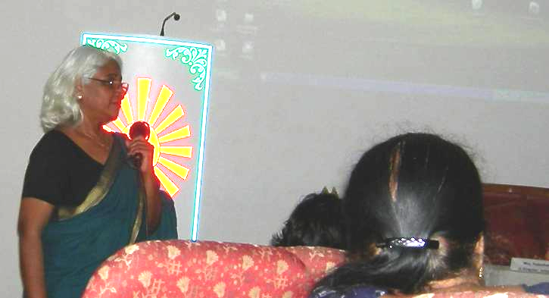
The materials as searched and complied have been divided into nine sections giving some practical suggestions. There are some specific chapters elaborating the systems and methods that need to be followed step-by-step to make it understandable, workable and accountable.

The monitoring and check on any programme is an integral portion which offers specific guidelines leading to reporting-monitoring both internally and externally.

Since the most important aspect is accounting and auditing, the primary objective is to keep the practicality as high as possible so that users could use this manual as a guide and even further develop systems that are locally accepted within the larger parameters of the principles of accounting and auditing.

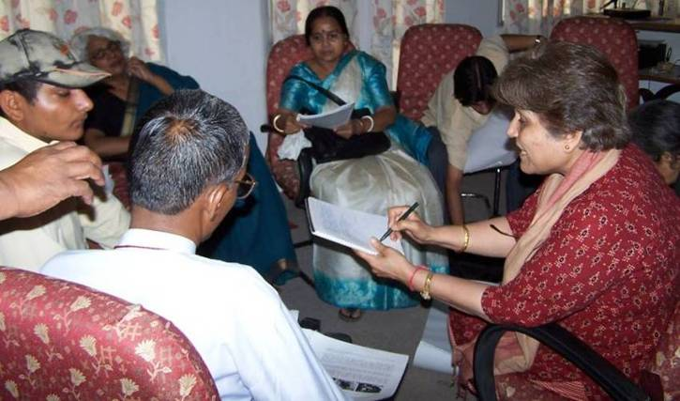
Participants were divided into three groups to discuss further on this manual section-wise with special emphasis on the responsive system. All the three groups were encouraged to take up feasible SETs as different case studies, action plan and decided on the follow up. The groups prepared the action plan and discussed the RETs duly moderated by the Co-ordinators. A process of participatory learning was progressed.

General impression revealed that all in all it was an interesting and absorbing interactive Session, which made the learning very enjoyable.

Day Three – 26TH May-2007

Feedback from the Participants

Mrs Kalpakam Yechury-AIWC, Joint Director of the workshop invited the participants to give their views and share suggestions.

Feedback from the participants included the following:

The session was coordinated by Dr. Ajit Seshadri and his student volunteers.

- Dr. Sushila Shah: She expressed her gratitude to the organizers of the workshop and said that this workshop will motivate people to create awareness and to implement skills learnt at the work shop. She also expressed her disappointment on non availability of grants from the government sources for RETs projects and that some arrangement to be made by the organizers to give insight as to how to source funds and implement them in the respective regions.

- Mrs . Shakuntala Mali:- She thanked the organizers and said that such workshops help in learning new things and gaining knowledge about new technologies useful in rural areas. She was also concerned with the non-receipt of government grants as mentioned by Dr. Sushila Shah.

- Mrs. Vijaya Rai:- She considered that it was a good gesture that the people discussed various practical problems realistically and gained practical knowledge also. She told her experiences of working in villages where there is no electricity and women along with their children work in kerosene lamp light to earn their living. She said that RETs such as solar lanterns etc. should be made available at these places. She also said that she got to know about organisations near her area and can now approach them for assistance and network. In the end she said that this workshop has been very useful.

- Mr. Shanker Agrawal:- He talked specifically about women empowerment and asked people to ponder upon the fact that in-spite of so much funds being spent by the Govt. women are still getting no benefits. He gave an example to the fact that women in certain regions are not getting their widow’s pension. He shared his experiences of rural areas where people are still very poor and said that we should give our best to the society. He said that we must go and talk to these people and he also suggested continuous connectivity among various organisations and prompt and thorough implementation of renewable energy technologies (RETs) for poverty reduction.

- Mr. M.S Gupta:- He suggested that we should gain inspiration from such workshops and implement these RETs in our areas in small sectors. He also asked NGOs to support programmes discarded by the Govt., if they believe in the implementation. If we work in capacity building then local official bodies will be under pressure to work and give support. He urged people to create difference by intervening and improving the condition and quality of living.

He said that instead of working on all the techniques we should develop expertise in our own field and then sell our ideas that are feasible. He requested to find resources and funds by mobilization our joint efforts and by networking. He also emphasized on the need of feedback of the work done by various organisations to AIWC. Mrs. Yechury seconded this and gave an example of employment generation in southern states.

- Mr. Promod Kumar:- He said that the conditions of villages was known to all and many programmes were undertaken by NGOs and government. He said that the lack of electricity is a major problem, so the solar PV lanterns should reach the villages. He also talked about Dalit community not getting benefits, and the capacity building opportunity in RETs should be utilized for their benefits as well.

- Ms. Purabi Pandey:- She said that she had registered her society and worked in solar energy for the first time and found this workshop very informative. She suggested to organizers to plan more such workshops and where she would plan to send her team, which will then further carry out the plan of feasible implementation of RETs.

- Ms. Tapsi Chanda:- She said that she will share the various concepts and ideas gained in the workshop with her working community and will give timely feedback. She also expressed her gratitude for the organizers of the workshop and said that she was able to learn a lot from it. She said that the amalgamation of science and social sciences is a very good idea and successful case studies should be propagated and she would help in this regard.

- Mr. Niranjan Sharma:- He was highly in favour of the preparation of manuals presented in the workshop. He mentioned that previously the information was available only in bits and in small measure and now these manuals have helped in integrating all the information holistically. He said that he will try to implement the work with the information and help got from the manuals. He was very impressed with the manual, its case studies etc. He also mentioned that he felt very good on meeting various people working in many fields of RETs. He also appreciated the entire environment of the campus, friendly and dedicated volunteers of ORC and the good facility at the venue of the workshop- which according to him helped in self improvement as well. Finally he said that he will disseminate the knowledge gained during this workshop and definitely give feedback and work for the betterment of the community.

10. Mrs. Shakuntala Mali seconded this and added that we need to pay attention to poverty, to which Mr. Niranjan Sharma added and suggested to under take promotion and implementation of RE technologies, like solar lantern among self-help groups to empower villagers and to achieve to goal of poverty reduction, by increasing their day-light hours for better productivity and enhancing the quality of life.

11 Mr. Parveen:- He was very much impressed with the solar equipments and said that he would transmit the knowledge to his own area of operation. He wanted the work to be concentrated for people in need.

12 Mr. Mahabir Prasad:- He talked about exchanging ideas with people working on same goals with various levels of experiences. He also said that it is necessary to provide training to women and children and emphasized on the importance of not just introducing techniques but also imparting knowledge on maintenance and repair of the equipments to ensure sustainability. He said that demand for renewable energy is increasing and financial problems should not limit their implementation. He also suggested having such workshop annually.

The feed-back session was concluded with appreciation to all the participants by one of the facilitator Dr. Ajit Seshadri of the Vigyan Vijay Foundation.
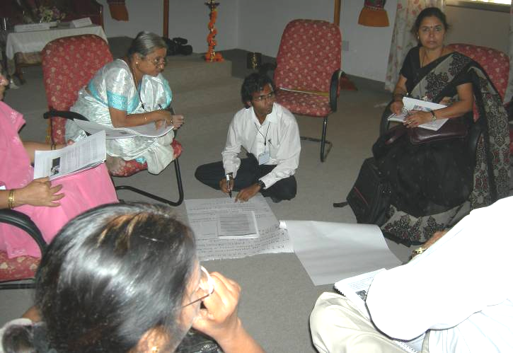
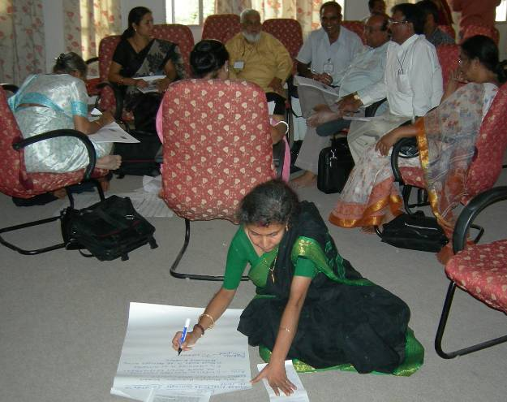
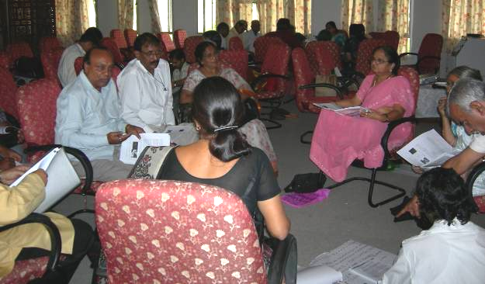
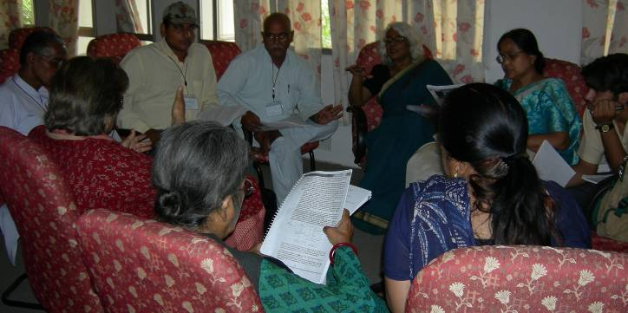
Mrs. Yechury proposed a vote of thanks and this session was concluded.

One Day National Seminar on Decentralized Power/Electricity Generation

The session began with a Bhajan (singing of hymns) presented by Mrs. Janaki Rajam, Senior Member -AIWC

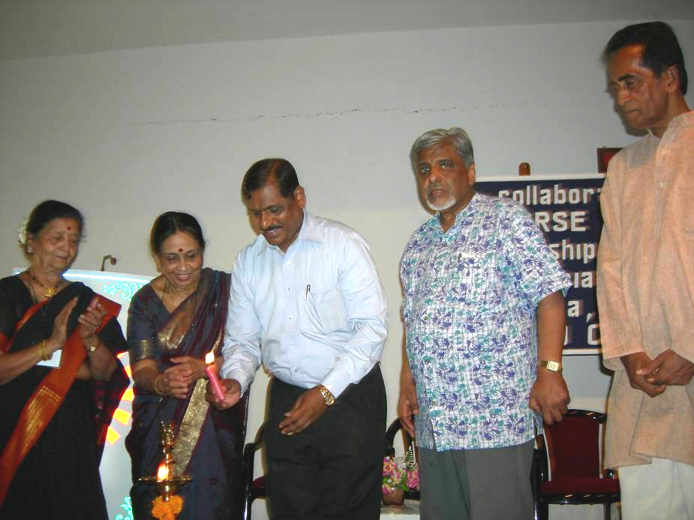
The Chief Guest Dr. R. N. Sawant, Director, MNRE, GOI chaired the Session and eminent speakers were members of the panel.

Dr. Sawant was welcomed by Mrs. Yechury. She introduced him and said that he is presently a Director, MNRE-GOI and an Advisor to the Minister, MNRE. He has been with this ministry for many years and is fully aware of the problems faced by the NGOs in promoting the RETs. Many NGOs seek his advice and he is always more than willing to extend his support.

The organisers and the participating NGOs were grateful that he had found time to be with us in-spite of his heavy commitment. At this time the Chief Guest was requested to light the lamp for formal inauguration of the day’s session.

Mr. Myles gave a complete background and purpose of the workshop for the benefit of the chief guest. He stated in brief the roles and the organizations- INFORSE, INSEDA (as the Regional Coordinator-South Asia) and AIWC, SDA (as national focal points-India) and their involvement in promoting the affordable RETs in and through their programmes with the sole purpose and generate employment and to reduce poverty.

INFORSE and INSEDA in collaboration with the national focal points (organisations) from Sri Lanka-Nepal-Bangladesh and India have brought out two Manuals i.e. SET (sustainable energy technologies) and financial manual for financing of RET through NGOs and other developmental organisations, by using micro-financing. This is a significant outcome which is based on years of ground experience in promoting RETs gained by INFORSE regional members and partners from South Asia and the international team (from Denmark) has worked on this for almost 18 months to give the final shape. Some portions of these manuals have been placed on INFORSE’s web-site.

He also emphasized the importance of capacity building of NGOs for poverty reduction and the inter-linkage of the network of NGOs. He briefly dealt on the topic of micro-finance, since this has assumed a greater significance in financing the RET’s in rural areas. He highlighted the successful example of Grameen Shakti, Bangladesh (INFORSE members and as one of the partners of this project) as to how they have involved the rural people in this enterprise of renewable energy and now it has assumed a world-wide reputation to solve the energy crisis in the rural areas of the developing countries, especially the far-flung and remote villages where perhaps electricity will never reach or take decade to come.

Key Note Address

In his Key Note Address Dr. Sawant said that he was happy to be at the workshop and appreciated the venue of the workshop and expressed his confidence that it will have a positive impact. He said that he has a different vision for NGOs . He talked about electricity and power generation using RETs. He also said that country has developed a lot in context of renewable energy programme.

Dr. Sawant in his interesting presentation elaborated on the roles –vision and programmes about Ministry of New and Renewable Energy
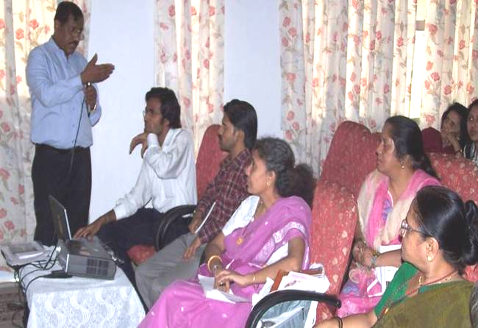
- Research, design and Development.
- Aim & Efforts to make industry effective.
- Strategies followed
- Projects actively supported R&D.
- Market oriented thrust.
- Focus on cost reduction and increase in efficiency
- R&D industry driven, goal oriented.
- Access technological development world wide
- 50% financial support from Ministry for Industries Registered with DSIR.
5. Monitoring - Macro indicators:
- Alternative fuel in liquid fuel mix .
- Renewable energy in energy mix.
Micro indicators:
- Share of indigenously designed, developed and manufactured Vehicle Sets , Wind pumps etc.
6. Area focus
7. System focus
8. Activities:-
- Development of technology, process components, subsystems, system
-Technical demonstration.
- Proto type development.
- Facilitate manufacture raising capacity utilizing factor.
9. Deployment aims – Grid power by renewable to be increased to 10% by 2012.
10. Proposed activities:
- Technological mapping
- Technological benchmarking
- Technological forecasting.
11. Inter linkage of the organisations was explained- TIFAD-R&D -NETCOF

Presentation by the Representatives of Resource Institutions

Bank Norms for Financing RETs Installations

The representatives of Canara Bank were invited to speak out their policies. Speaking on their policies of providing soft loans for the propagation of RETs, Mr. Mishra, the Chief Manager, gave a brief history of Canara Bank which was a leading bank in India and which has completed 100 Years of its glorious existence with the main motto of customer satisfaction. They had received a lot of appreciation for their work in financing of solar energy utilizing projects.
Mr. Pandey dwelt on the economics of solar energy, green house effects, ozone and climate change. They have been financing solar water heater (Cost Rs. 17000 – 20000), which is more efficient and helps in saving 1000 units of electricity and 100 litres of water every day. He talked about soft loans and mentioned that Canara Bank had earned rewards in developing soft loans schemes for solar water heater. He gave relevant details about the effective rate of interest for domestic, institutional and commercial purposes. The eligibility of these loan schemes were discussed such as EMI Schemes- PAN card- Address proof etc.
The presentation led to an open discussion between the bank representatives and the workshop participants where the questions regarding getting loans/ support from near by branches, special facilities for women, SHGs etc. were discussed.

Financing of RETS by IREDA (Autonomous Agency Under MNRE)

Mr. R.K Vimal from IREDA was invited to give his presentation. IREDA, (Indian Renewable Energy Development Agency’s) role in power generation was explained and the available technology options including IREDA’s beginning, promotion and financing RETs, objectives, sectors, financing norms, various projects (Biomass Power Project, Biomass Gasification, Solar Photovoltaic Street Lightning System, Hydro power plant, Wind power etc.) were also presented. The topics of Bio fuels, Bio- diesel and ethanol and IREDA norms for these, MNRE– subsidy scheme for Biomass Gasification, Promotional Initiatives etc. were also explained.
This was briefly followed by an open discussion. Mrs. Vijaya Rai and Mrs. Zareen Myles put forward some critical questions in extending financial support to the poor. Mr. Niranjan Sharma asked about training programs to be organized. Fr. Mathew then talked about the need of fruitful and effective network between NGO’s and SHG’s.

Solar Energy Installation at OSRC, Bramha Kumaries, Manesar

Mr. Chandrakant, member, OSRC explained the Solar system installed with parabolic Reflectors. The system was developed by a Swiss scientist and was first installed at Mount Abu Centre. A leader pipe is made of heavy steel material and remains half full with water. It receives focused solar heat and utilizes it for cooking. Safety valves are installed to remove excess steam generated. The reflectors are made synchronous with the sun so that it can receive heat at all the time. Electricity / power consumption in the OSRC is very high, and the supply has now become reliable owing to the solar energy utilization with the use of solar PV panel of capacity of 200kw.

Resource Person from Swiss Development Coopertion (SDC)

Dr. Veena Joshi (SDC) talked about the research related to energy and finance. She said that giving loan to villagers was not a solution as it increases loan burden of completion. She also said that we should think of renewable energy as the first option and not the last option. She said that there was a need of complete networking of small and micro learning enterprises. She gave a small but interesting presentation. According to her, thermal has the maximum potential, then she talked about her experience of four projects.

Resource Person from India Canada Environmental Facility (ICEF)

Dr. Bhaskar Natarajan (ICEF) talked about rural energy used for lightning, cooking. In his short presentation he talked about ICEF and its mandate, some practical aspects of some of his projects in the following areas:

(A) Sagar project Results:
- Four units of 50 kw commissioned.
- Electricity from Wind Turbine is being generated.
- Wind penetration of 16%, some time up to 30% recorded.
- 6000 families, schools, institutions have gained from this project a positive effect.
- Sagar hydel electric corporate established.
Now people are owning, running & using the system on BOOT principle.

(B) Len Project Results:
  - 100kw solar grid power plant commissioned and supplying electricity from March 2005 onwards,
2. 1000 homes have solar cookers, improved chulhas and home insulation.
> Income generation activities practiced;
> Capacity building of local institution done; and
> Eencouragement of women members propagated.

(C) BERI Project Results:
- 500 kw gasifiers commissioned to be ready for commercial operation;
- Four gasifiers of 10 kw installed in four districts as demo units;
- Over 3000 hectare of captive land to derive biomass;
- Currently working with govt. (state and central) coherently.
The presentation was followed by an open discussion.

Closing Session

The felicitation of guest speakers by Mrs. Lalita Balakrishnan (AIWC and INFORSE National Focal Points-Gender) was followed by the concluding remarks by Mr. Raymond Myles (INSEDA and INFORSE-South Asia) and then vote of thanks by Father Matthew Vadakemuriyil (SDA and INFORSE National Focal Points-General).

Sister Asha then talked about “Spirituality, wealth & happiness” and the session concluded with instructions to participants to take up follow up action in the respective regions and with grass-roots NGOs.

Conclusion and Recommendations

NGO Statement
India is probably the single country in the world with most people without access to clean energy solutions for cooking and heating and without basic electricity services. At the same time India has one of the fastest growing economies; but the growth leaves most of the poor people behind, especially those living in the rural areas of the country, leading to:
- social inequality,
- social unrest; and
- energy poverty, leading to other form of poverty
The NGO also recognise that the development of the human resources that will be needed for future growth and sustainable development of the country and the people, especially for the benefit of the poor. Thus the NGO representatives participating in these two important events of three days duration, in the country namely workshop on SET for poverty reduction and Seminar on decentralised electricity/power generation recognise the urgent need for the promotion and implementation of:
- clean- environmentally sustainable, and
- affordable, and reliable energy solutions,
As part of the way out of poverty for the majority of poor people, the solutions must be based on locally available resources to be affordable and reliable: renewable energy should be used efficiently. While India has led this development with a number of solutions from biogas plants to "Smokeless Chulha", the activities must be increased, combining new and old solutions. The Government of India has a key role to play as the largest body with responsibility for poverty reduction and with its ability to reallocate finances between sectors. The state must set a target of increasing efforts to provide basic energy solutions, with the efforts increasing annually with the economic growth of India. NGOs are important mediators, and Indian NGOs have played crucial roles in bringing energy solutions to the people, and are ready to continue the work as the current collection of successes show.
NGOs participating in this Workshop and Seminar whole heartedly support the promotion and implementation of sustainable and renewable energy, especially for poverty reduction through environmentally sustainable techniques.
The NGOs present here support the target proposed by the WHO to reduce by half, by 2015, the number of people with out basic energy services. This must be based on the renewable energy services used in sustainable ways.
In this connection we suggest the following concrete actions:
- Capacity building of all the stake holders, especially the NGOs, CBOs and other Micro level People’s Institutions (MLIPs). This should include post installation, maintenance and repairs with a professional approach.
- Implementation of energy conservation and energy efficiency measures.
- Make available resources for the implementation of decentralized, people/community managed affordable and sustainable, power/electricity generation systems.
- Making available seed funds/money to NGOs for the implementation of micro finance based RETs for poverty reduction thus environmentally sustainable techniques.
- Put in place organizational mechanism to promote dialogue between the government and local NGOs to effectively promote and implement practical solutions in RETs for poverty reduction.
- Environmentally sustainable production of bio-fuel (bio-oil straight vegetable oil-SVO and bio-diesel) from non-edible oil seeds, like Jatropha grown on bunds of the fields and degraded lands and other fields which are not suitable for food production, as well as grown along the railway tracks and highways etc.
- Tax exemptions fro components of RE such as home lighting system and appliances and biogas plants and agricultural linked gadgets so that the cost is kept low enough to make it affordable for the group concerned.
- Appropriate guidelines to be worked out by the nodal Ministry of the Government of India and NGO’s.
- The policy makers and government should politically support Ministry of Finance RE promotion programme involving NGOs and provide appropriate subsidies in and should make these available to the poorest of the poor through appropriate policies arrived at in consultation with the NGOs and groups concerned.
As a part of the INFORSE South Asia project on capacity building of NGOs on RETs for poverty reduction in Asia, two manuals in English have been produced by INSEDA and INFORSE Regional Support Unit (RSU) in partnership of the INFORSE National Focal Points in the four countries including India and actively supported by our two partners from Denmark (OVE & DIB) as well as the INFORSE International Secretariat. The SET manual has also been translated in to four local languages (Bangladesh, India, Nepal and Sri Lanka) for capacity building of NGOs and dissemination of information for all round awareness creation in South Asian region. These two manuals are:
- Manual on Renewable Energy Technologies for Sustainable Energy Solutions for poverty reduction in South Asia and
- Financial Manual for Micro Financing based Sustainable Energy Solutions for Poverty Reduction in South Asia.
We the participants present here strongly recommend that these two manuals should be used in training NGOs as Trainers and should be widely distributed in India, South Asian Region and other countries. However, for these two manuals to be more useful under grassroots situations, they need to be translated in all the local languages of the different states of India.
Therefore, INSEDA and INFORSE should contact appropriate donors for the translation of these manuals in all the official languages of the different states of India; and also for initiating systematic and long-term programme for the capacity building and disseminating of information on RETs using these two manuals as well as for the implementation of RET based Sustainable Energy Solutions for poverty reduction through NGOs, integrating them with their other development programmes.

Press Note

A capacity building national level workshop for grassroots NGOs drawn from seven states was conducted for two days by INFORSE- South Asia and All India Women’s conference (AIWC) in partnership with INSEDA and SDA on 24 & 25 of May 2007.

The aim of the workshop was to find sustainable energy solutions for poverty reduction, income generation & upgrading of the living conditions of the women at the grass roots.

Dr. (Mrs.) Manorama Bawa, President AIWC, welcomed the gathering- she told the participants that AIWC was one of the pioneering organizations to take renewable energy technology to the grass root women.

Mr. Raymond Myles, INFORSE Regional Coordinator and Secretary General, INSEDA welcomed the participants on behalf of the INFORSE South Asia and presented the theme & approach paper for the workshop.

Mr. V. Subramaniam, Secretary, Ministry of New & Renewable Energy (MNRE), Govt. of Inida was the Chief Guest and inaugurated the workshop.

In his inaugural statement he declared that there is a lot of scope for improving the energy situation, utilizing renewable energy technologies.

He also emphasized that role of energy devices is the key input to all factors required for the survival of human being and for realizing social development in communities.

The workshop was conducted at Om Shanti Retreat Centre (OSRC), Brahamkumari Ashram, Manesar, Gurgaon where the renewable energy resources have been put to use on a practical level. The participants learnt the concepts with an aspiration to propagate and to take up the role as trainers at grassroots level.

The Secretary, MNRE assured the participants and organizers of the workshop that he would always be supporting encouraging energy initiatives in the rural sector.

General Obseervations:

Upon completion of the training workshop for 2 days, participants have become aware of Renewable Energy Technologies and would work towards making them Sustainable Energy technologies.

Participants could aim to work towards propagating appropriate energy Solutions, The specific components gained during the training are:

- Base line survey: Key elements assets in a community as per the Community Asset Management check list points elaborated to NGO’s, On site specific data and adapting survey manual, training module for planning and implementation, some idea about Energy Security & Efficiency in the region, the general gains in the community assets by way of social, economic, environmental health, phasing out of fossil fuels, CDM’s (community development mechanisms), carbon credits etc.
- Techno commercial manual: General idea about the manual: manual formulation, training for the grassroots workers; making them aware of the cooking, lighting, cooling, heating, radio, TV, communication, low technology transfer that are feasible to progress. Post installation maintenance an important aspect.
- Financial manual: Basic costs, running & maintenance costs, productivity gains direct or indirect, fund raising, cost benefit assessment, income & assets in communities, successful models of energy generation.
- Organized solutions: For poverty reduction and gender equity and improving the quality of living at rural and urban locations, community involvement, women & youth in small business solutions, NGO’s participation.
- Holistic approach: Review successful cases and assets regarding replication at respective areas, increase networks, outreach & communication, awareness and participation and propagation & replication of sustainable energy solutions, to maintain a cascading growth, commence a pilot project to assess the feasibility and the capability of the project to bring in money returns in order for providing both poverty reduction and self employment.
- Energy initiatives, some examples: Improved chulhas, human/ animal power, biogas, briquettes, SPV & solar, thermal, wind, Microhydel ; Hybrid rural energy initiatives for rural & urban poor/ micro credit schemes with organizations; Microhydel biofuel, hydrogen, waste to energy, encourage women & youth entrepreneurship in their areas.
- Way forward: plan & execute feasible initiatives for poverty reduction & income generation, upgrade living conditions at the grassroot level.
- Conclusion & recommendations: It is suggested that participants give their impressions & valued comments about aspects that they learned & some views as to how they would take the initiative forward.

What support would they wish from AIWC as per the checklist given?
- Techno commercial manual: General idea about the manual: manual formulation, training for the grassroots workers; making them aware of the cooking, lighting, cooling, heating, radio, TV, communication, low technology transfer that are feasible to progress.
- Financial manual: Basic costs, running & maintenance costs, productivity gains direct or indirect, fund raising, cost benefit assessment, income & assets in communities, successful models of energy generation.
- Organized solutions: For poverty reduction and gender equity and improving the quality of living at rural and urban locations, community involvement, women & youth in small business solutions, NGO’s participation.
- Holistic approach: Review successful cases and assets regarding replication at respective areas, increase networks, outreach & communication, awareness and participation and propagation & replication of sustainable energy solutions, to maintain a cascading growth, commence a pilot project to assess the feasibility and the capability of the project to bring in money returns in order for providing both poverty reduction and self employment.
- Energy initiatives, some examples: Improved chulhas, human/ animal power, biogas, briquettes, SPV & solar, thermal, wind, Microhydel ; Hybrid rural energy initiatives for rural & urban poor/ micro credit schemes with organizations; Microhydel biofuel, hydrogen, waste to energy, encourage women & youth entrepreneurship in their areas.
- Way forward: plan & execute feasible initiatives for poverty reduction & income generation, upgrade living conditions at the grassroot level.
- Conclusion & recommendations: It is suggested to give their impressions & valued comments about aspects that they learned & some views as to how they would take the initiative forward.

What support would they wish from AIWC organization as per the checklist given?

ANNEXURES

Annexure – I

Programme Schedule

24THMay 2007, Thursday

08.30 am – 09:00 am | Assembly & Registration
09.00 am- 10.00 am | Campus Visit
10.00 am. – 11 00 am | Address by Sister Asha, Director, ORC  On Stress Management
11:00 am – 01:00 pm | Inaugural Session
Lighting of the Lamp

Welcome | Dr. Mrs Manorama Bawa  President-AIWC
Felicitations | Mrs. Kalpakam Yechury  Member-in-Charge Sanitation, AIWC  Jt. Director - Workshop
Introduction of the  Workshop | Shri Raymond Myles  Asia Coordinator – INFORSE
Introduction of the Chief Guest | Mrs. Lalita Balakrishnan  Director – Workshop & National Focal  Coordinator for INFORSE (Gender)
Inaugural Address | Mr. V. Subramaniyam , IAS  Secretary- MNRE -GOI
Closing Remarks & Vote of Thanks | Mrs. Rakesh Dhawan Hon. Treasurer,AIWC
01.00 pm – 2.00 pm | Lunch
02.00 p.m. – 2.30 p.m. | Presentation by Ms. Swati Bhogle, TIDE (Bangalore)
02:30 pm – 03.45 pm | TECHNICAL SESSION - I  (GUIDELINES : CHOOSING RIGHT RET SOLUTIONS)  - Presentation on Survey Conducted in the villages of Haryana & Rajasthan  - Presentation of Calculations / Exercise to determine correct options of RET  - Group Discussions
03:45 pm – 04.00 pm | Tea
04:00 pm – 06.00 pm | TECHNICAL SESSION – II  (SOLUTIONS : SUSTAINABLE ENERGY TECHNOLOGY)  - Presentation  - Group discussion

Day Two- 25TH,May 2007

Time | Event | Program details
10.00 a.m. to 11.00 a.m. | Presentations and  Group Discussion | Technical Session 3: Local Organisations managing Sustainable Energy Technologies (SETs)
11.00 a.m. to 12.00 noon | Inaugural Session  Chief Guest  Welcome Address and Introduction of Chief Guest | Dr.V.N.Rajasekharan Pillai, Vice-Chancellor,IGNOU.  Dr.Mrs.Jaya Kothai Pillai,  Secretary General, AIWC.
 | Inaugural Address by Chief Guest | Dr.V.N.Rajasekharan Pillai,  Vice-Chancellor,  Indira Gandhi National Open University
 | Talk on  Distance Education & INFORSE | Mr. Raymond Myles,  Secretary INSEDA.
 | Remarks on Workshop | Mrs. Lalita Balakrishnan,  Member-in-Charge-Energy, AIWC
 | Vote of Thanks | Fr. V. Mathews Chairman, SDA
12.00 noon to  1.00 p.m. |  | Presentation of three Group Reports  (Technical Session I, II & III)
01.00 p.m. to 2.00 p.m. |  | LUNCH

Day Three-26TH May, 2007

National Seminar on Decentralised Power/ Electrcity Generation
Time | Event | Program details
 | Arrival of Chief Guest | Dr. R.N. Sawant,  Director, MNRE
9.30 a.m. | Felicitation & welcome | Mrs. Kalpakam Yechury,  Jt. Director – Workshop  & Member-in-Charge Rural Sanitation, water & Waste Management,AIWC
9.40 a.m. | Aims & Objectives of the Seminar | Mr. Raymond Myles,  Secretary General - INSEDA
 | Panel Discussions | Chaired by Dr. R N Sawant, Director, MNRE, RET program
 | I | Dr. R.N. Sawant, Director, MNRE  RET program with emphasis on Research & Development
 | II | Soft Loan & Concession for Procurement of RET Devices by officials of Canara Bank.
 | III | Challenges in Providing Energy Process by  Ms. Veena Joshi, Head, Energy and Rural Housing  Swiss Co-operation Office, New Delhi
 | IV | ICEF Experience on Decentralised Power Generation – Sh. Bhaskar Natrajan, Senior Project Officer,  India-Canada Environment Facility, New Delhi.
 | V | IREDA Schemes and interest subsidy by  Mr. R.K. Vimal  Manager (TS) - IREDA
 | VI | Case Studies-on the three RETs in use at ORT by  Sh. S. Gupta, Engineer, ORC, Gurgaon
1.30-2.30 p.m. | LUNCH
2.30 – 3.30 p.m. | Closing Session
3.30 p.m.-4.30 p.m. | Chair | Mr. Raymond Myles, Regional Coordinator, INFORSE
 | Co-Chair | Mrs. Lalita Balakrishnan, Member-in-Charge, AIWC & Coordinator national Focal Point INforSE (Gender)  Fr. Mathew Vadakemuriyil, Chairman, SDA, Coordinator National Focal Point INforSE
Road Map for the Future Plan of Action
Sh. Pradeep Chaturvedi, Chairman
Indian Association for the Advancement of ScienceWomen
 | Vote of thanks | Father Mathews V. Chairman, SDA
Annexure II

List of participants

Dr. Manorama Bawa, President,AIWC,
6 Bhagwan Dass Road,
New Delhi 23389680

Dr. Jaya Kothai Pillai, Secretary General,AIWC
6 Bhagwan Dass Road
New Delhi 23381165

Smt. Rakesh Dhawan, Hon. Treasurer, AIWC &
President – AIWC Sahaspur Rural Branch
7/1 Pritam Road,
Dehradun-248 001 23381165

Mrs. Lalita Balakrishnan,
Member-in-Charge Rural Energy & Director – Workshop
& Coordinator – National Focal Point (Gender) INFORSE
6 Bhagwan Dass Road, New Delhi 23389680/2686463
E-mail : lalitabalakrishnan@gmail.com

Mrs. Kalpakam Yechury,
Member-in-Charge Rural Sanitation
Water & Waste Management,AIWC & Jt. Director- Workshop
6 Bhagwan Dass Road, New Delhi 23389680

FR. Mathew Vadakemuriyil,
Chairman -Sustainable Development Agency (SDA),
Parathode, Kanjirapally-686 507, KERALA Tel: (04828)-270546;
Fax: (091)-(48280)-3356
E-Mail: infarm@rediffmail.com

Mr. Raymond Myles,
Secretary General-cum-Chief Executive
Integrated Sustainable Energy and Ecological, Tel: (011)-2551-0344 & 2554-4905
Development Association (INSEDA) Fax: (091)-(11)-2552-9646
& Regional Coordinator, INFORSE Mobile:09350558992
3rd Floor, St. Solider’s Tower, E-Mail: raymyles@bol.net.in,
Vikas Puri, NEW DELHI-110 018. ray_myles05@yahoo.co.in

Mr. Sushil I. Parmar, Director,
Joseph Institute for Rural Development (JIFORD),
Bhatpar Rani-274702 Tel: (Bhatpar Rani): (05566)-7113
District-Deoria, UTTAR PRADESH Tel: (Delhi Office): (011)-2373-4377

Mr. U.L. Bangerwal,
General Secretary, Emmanuel Social Association (ESA)
Muyal’s House, 28/2, Laxmi Road,
Dalanwala, Dehradun-248 001, Tel: (0135)-675-209 & 670-239
UTTAR PRADESH Fax: (091)-(135)-675-209

Ms. Zareen Myles,
Executive Director,
Women’s Action for Development (WAFD),
3rd Floor, St. Soldier’s Tower, Tel: (011)-2552-6521& 2551-0344
Vikas Puri, Near Sonia Cinema, Fax: (091)-(11)-2552-9646
NEW DELHI-110 018 E.Mail:zareenwafd@w3c.com

Mr. Niranjan Sharma,
Director, Social Action for Human
Resource Development (SOHARD),
Village Anandpur, P.o. Mandan 01494 244024
District-Alwar-301 704. Rajasthan. sohardpr@yahoo.com

Mr. Mahavir Prasad Bhardwaj,
Director, Dehat Vikas Kendra
Village & P.O. Dongra Ahir
Block Kanina, Dist. Mohindergarh-123021
HARYANA Ph: +91 1285-6719

Mr. M.I. Khimla,
Director, New Life Centre (NLC)
Village Banjali, Sailana Road,
Ratlam-457 001. MADHYA PRADESH Tel: 35207 & 40216

Mr. Manoranjan Kumar,
Samagra Vikas Mission
Nichali Kula, Garhpar
Bihar Sharif, Dist. Nalanda, Bihar-803101 Mobile - 9835601611

Mrs. Janaki Rajaram,
President, South West Delhi Women’s Association
Shankara Vidya Kendra,
Pachimi Marg, New Delhi-57. 24112892

Mrs. Shobha Lal, Gurgaon Gramin Mahila Mandal
Plot No.310, Sector-39, Gurgaon-122 001. shobha_rural@rediffmail.com

Ms. Taposhi Chandra, C/o CDR H.B. Chandra
109/C Grey Street
39 Aurbindo Sarani 9231586023
Kolkata-700 005 hatchanduz@yahoo.com

Mrs. Shashi Yadav, Director, AIWC Branch Rewari
26, Industrial Area, REWARI-123 401, HARYANA.

Dr. Sushila Shah, AIWC Jalgaon Branch
Post Box No. 1, CHOPDA Distt.,
Jalgaon 425 107 (Maharashtra) Ph. No. 0141 2565250

Mr. Akif Farooqui, Asst. Manager-Marketing
COSMOS IGNITE INNOVATIONS Tel: 91-11-26491546/41748540
C-25, First Floor, Panchsheel Enclave Fax: 26491910
New Delhi-110 017. e.mail: akif@cosmosignite.com

Ms. Purabi Pandey,
Facilitator,Surendra Solar Energy Society,
G-16 Hospital Area, Nilokheri- 132117, 9896697343
Karnal, Haryana purabipandey@hotmail.com

Dr. Mrs. Ramesh Madan, Asstt. Director, (ICSSR)
Indian Council of Social Science & Research
Aruna Asaf Ali Road, 9818734765
New Delhi. meshimadan@gmail.com

Mrs. Jaya Ramakrishnan,
Treasurer – Women’s Indian
Association, Chennai, 10 East Abiramapuram
3rd Street, Mylapore 033 24662471
Chennai 600 004 krish_ramki@hotmail.com

Mr. Sushil Rajput,
Sagar Khadi Hram Udyog Samiti,
Haridwar, Bijnour.

Mr. A. K. Khater,
1231124, Third floor, Phone No. 26879395
Satya Niketan New Delhi 110021 akhater@bol.net.in
Mrs. Shakuntala Mali,
Panchiashwar, Gillital- Chopra district
Jalgaon, Vijaypurm mandal 09822448281

Mr. Narayan Singh, OSD, WAFD Bharatpur
Plot No.61, 62 Yeah vihar colony, 05644-228772
Brig-ghasi Ram Marg Bharatpur, Rajasthan 09414712532

Ms. Rachna, Student –
Delhi College of Engineering Ph: 011-25085317
WZ-557 Palam, 09213624267.
New Delhi 110045. rachna.curiousalways@gmail.com

Mr. Parvin Sharma,
Samaj Vikas Prayatna Kendra
Sohansara 127201. District Bhiwani (Haryana) 01252-254020

Mr. Mahabir Prasad Bhardwaj,
Director, Dehat Vikas Kendra
Village & P.O. Dongra-Ahir,
District Mohindergarh Haryana 01285-243719

Ms. Kusum Menon
Surendra solar society D-II/67 , 23074096
Pandara Road New Delhi 110003 9818032003
Kusummenon4@hotmail.com
Mr. Anoop Sharma, Post Graduate Student
MGIIREDP, Bakoli, Ph. No. 9999398630
Alipur,Delhi 110036 Email : Anoopsharma2210@gmail.com

Er. M.S.Gupta, Director,
Sarvangeen Vikas Samiti Gehwan Sagar
(New Shivpuri Colony) Gorakhpur UP 273016 9451957305 Svsgkp2002@yahoo.com

Mr. Prakash Manwar Flat No. 363
Type III ( AIIMS campus) Ayurvigyan Nagar
Khelgaon marg New Delhi 110049 011-26259689
9212792236
Prakashmanwar@gmail.com
Adarsh Kumar Pandey Post Graduate Student
MGIIREDP, Bakoli
Delhi 110036 9999398245
Adarsh_889@gmail.com
Mr. Arun Kumar, Post Graduate Student
MGIIREDP, Bakoli, Alipur
Delhi 110036 9999189636
Arun_456@yahoo.co.in

Mr. Navin Singh, Post Graduate Student
MGIIREDP, Bakoli, Alipur
Delhi 110036 9999237249
Navin007@rediffmail.com
Mrs. Suguna Swaminathan,
Forum of Women in Public Sector
BHEL House, Siri Fort, Asiad Village
New Delhi 110049 011-26001051/ 9810638110

Chief Guests
Dr. B.K Asha, Director, Om Shanati,Retreat Centre, Manesar, Gurgaon
Mr. V. Subramaniyam,Secretary, MNRE-GOI
Dr. V.N.Rajasekharan Pillai, Vice-Chancellor, IGNOU, New-Delhi
Dr. R.N.Sawant, Director, MNRE,GOI

Resource Persons
Dr. (Mrs.) Veena Joshi, SDC,New Delhi
Mr. Vimal Kumar, IREDA,New Delhi
Dr. Bhaskar Natarajan, ICEF,New Delhi
Mr. Mishra, Mr. Pandey, and Mrs Saroj Sachdeva, Canara Bank
Mr. Pradeep Chaturvedi, New Delhi
Dr. Ms. Swati Bhogle, TIDE, Bangalore
Mr. Chandrakant, RET- OSRC ,Gurgaon
Fr. Mathew Vadakemuriyil, SDA Kerala & INSEDA, New-Delhi
Mr. Raymond Myles,INFORSE-INSEDA,New-Delhi & Co-organiser–Workshop & Seminar
Mr. Prakash Manwar, Development Facilitator, New Delhi
Mrs. Zareen Myles, Exexutive Director, WAFD

Office Bearers of INSEDA
Fr. Mathew Vadakemuriyil,Chairman, INSEDA
Mr. Raymond Myles, Secretary-General –cum Chief Executive Officer, INSEDA, New Delhi

Office Bearers of AIWC
Dr. Mrs. Manorama Bawa, President-AIWC
Dr. Mrs. Jaya K. Pillai, Secretary General-AIWC
Mrs. Rakesh Dhawan, Hony. Treasurer, AIWC
Mrs. Lalita Balakrishnan, Workshop Director & Member-in-Charge Rural Energy, AIWC
Mrs. Kalpakkam Yechury, Joint. Director, Workshop & Member-in-Charge Rural Sanitation, Water, Sanitation & Waste Management, AIWC.

Team Of Facilitators:
Mrs. Suguna Swaminathan
Dr. Ajit R. Sheshadri
Three Engineering Student Volunteers
Mr. Prakash Manwar and
Mrs. Zareen Myles

Support Team:
Mr. Panicker
Ms. Anita Wason
Ms. Manju Parasar
Ms. Lily Arora
Ms. Suman Bhagotra
Ms. Kamlesh Bhardwaj
Ms. Savita Sharma
Ms. Sunita Sareen

Representatives of INFORSE South Asian Region:
Mr. Raymond Myles, INFORSE Regional Coordinator-South Asia
Fr. Mathew Vadakemuriyil, INFORSE National Focal Point-India (General)
Mrs. Lalita Balakrishnan, INFORSE National Focal Point-India (Gender)
Annexure III

List of Group-wise Particpants

Group-1: Krishak Bandhu (KB) Group

Repertoire Yogesh Kumar Harle, Room no 009, student Hostel, M.G.I.I.R.E.P.D, Bakoli
Alipur, Delhi-110036 - Ph No- 09999220257 Email- yogeshharle@gmail.com

Name | Address | Contact No. | E-mail ID
Mr. A. K. Khater | 1231124, Third floor, Satya Niketan New Delhi 110021 | 26879395 | akhater@bol.net.in
Mrs. Vijaya Rai | Chunar, Mirzapur, U.P. 231304 | 05443-222256 | Unnayansansthan@sify.com
Dr. Susheela Shah | Sarajini house  6, Bhagwandas Road ,  New Delhi110001 | 011-23389680  011-23381165 | aiwcctc@nda.vsnl.net.in
Mr. G.D. Sharma | Kalibari, kathua, Jammu & Kashmir-184204 | 09419152369
Mr.Shanker Agrawal | C-140, rajaji puram Lucknow U.P. | 0522-3941336  09918640480 | shankeragrawal@yahoo.co.in
Mr. M.L. Khimla | Vill. Banjali sailana Road, Ratlam M.P. | 07412-235207 | Newlife_rlm@sancharnet.in
Mrs. Shakuntala Mali | Panchiashwar, Gillital- Chopra district Jalgaon  Vijaypurm mandal | 09822448281
Mr. Narayan Singh, OSD, WAFD Bharatpur | Plot No.61, 62 Yeah vihar colony Brig-ghasi Ram Marg Bharatpur, Rajasthan | 05644-228772  09414712532
Mr. S.L.Parmar
Mr. S.D. Mishra | Joseph Institute of Rural Development  Mission Compound  Bhatpar rani Deoria U.P. | 09838285653  Fax: 05566-283113

Group-2: Grameen Bandhu (GB) Group

Repertoire: Rachna, WZ-557 Palam, New Delhi 110045. Ph: 011-25085317
09213624267. Email ID: rachna.curiousalways@gmail.com

Name | Address | Contact No. | E-mail ID
Mr. Niranjan Sharma, Social Action for HRD | Village Anandpur  P.O.mandan 301704  District Alwar (Rajasthan) | 01494-244024 | sohardpr@yahoo.com
Mr. Parvin Sharma | Samaj Vikas Prayatna Kendra  Sohansara 127201  District Bhiwani (Haryana) | 01252-254020
Mr. Mahabir Prasad Bhardwaj  Director, Dehat Vikas Kendra | Village & P.O. Dongra-Ahir  District Mohindergarh Haryana | 01285-243719
Ms. Purabi Pandey  Chairperson Surendra solar society | 16G Hospital Area First floor  Nilokheri District Karnal 132117 Haryana | 9896697343  9354175366  01745-320886 | purabipandey@hotmail.com
Ms. Zareen Myles | Women’s Action For Development  Third Floor  St. Soldier tower  Vikaspuri New Delhi 110018 | 9868281915 | Wafd078@yahoo.co.in
Ms. Kusum Menon  Surendra solar society | D-II/67 , Pandara Road New Delhi 110003 | 23074096  9818032003 | Kusummenon4@hotmail.com
Dr. Mrs. Ramesh Madan | Assistant Director  ICSSR,N-Delhi | 4217596  9818734765 | meshimadan@gmail.com
Mrs. Tapasi Chanda | C/o H B chanda  P-12717 Bally Gunj Maidan camp, Kolkata 700019 | 65193657  9231586023 | hatchanduz@yahoo.com
Mr. Varun Kumar | CD-249, Pitampura, New Delhi | 09871265510 | Varundce87@gmail.com

Group-3: Eco-Friendly (EF) Group

Repertoire: Anoop Sharma ,MGIIREDP, Bakoli, Alipur,Delhi 110036
Ph. No. 9999398630 Email ID: Anoopsharma2210@gmail.com

Name | Address | Contact No. | E-mail ID
Mr. Sushil rajpoot | Estate Shahpur  Haridwar Road  Bijnour UP 246749 | 01341-224974  01341-224022  9837721215 | sagarkhadi@yahoo.com
Mr. Manoranjan Kumar` | Samagra Vikas Mission, Nichli Kila( South of harijan thana)  Bihar Sarif, Nalanda | 9835601611
Er. M.S.Gupta | Director, Sarvangeen Vikas Samiti Gehwan Sagar (New Shivpuri Colony) Gorakhpur UP 273016 | 9451957305 | Svsgkp2002@yahoo.com
Mr. Prakash Manwar | Flat No. 363  Type III ( AIIMS campus) Ayurvigyan Nagar  Khelgaon Marg New Delhi 110049 | 011-26259689  9212792236 | Prakashmanwar@gmail.com
Mr. Adarsh Kumar Pandey | MGIIREDP  Bakoli, Delhi 110036 | 9999398245 | Adarsh_889@gmail.com
Jaya Ramakrishnan | Asst. Secretary AIWC, 3A,Ramnivam  Kalyani 44, Abhiramapnam  Fourth street Chennai | 033-24662471 | Krish_ramki@hotmail.com
Mr. Arun Kumar | MGIIREDP  Bakoli, Alipu, Delhi 110036 | 9999189636 | Arun_456@yahoo.co.in
Mr. Navin Singh | MGIIREDP  Bakoli, Alipur, Delhi 110036 | 9999237249 | Navin007@rediffmail.com
Ms. Shobha Lal | Gurgaon, Gramin Mahila Village, Alta- Mewar |  | Shobha_rural@rediffmail.com
Mrs. Swaminathan | Bhel House Sri Fort  New Delhi 110049 | 011-26001051  9810638110
Mrs. Shashi Yadav  Director-AIWC Rewari Branch | 26-Industrial area  Rewari 123401, Haryana | 01274-254194  01274-254555 | yadavsim@gmail.com

Annexure IV

Feedback Form for Participants

Please give your views/ impressions/ valued comments in the format as furnished below:

- What are your views about making a base line survey to make a community asset management (CAM) manual? Will this be useful for the community? ( 30 words)

- Have you got some basic idea about the RET’s & SET’s? What initiative will you consider to propagate in your region? (30 words)

Please give your views/ impressions/ valued comments in the format as furnished below:

- What are your views about making a base line survey to make a community asset management (CAM) manual? Will this be useful for the community? ( 30 words)

- Have you got some basic idea about the RET’s & SET’s? What initiative will you consider to propagate in your region? (30 words)

- What type of support do you look for in propagating appropriate initiatives in your area? (30 words)

- Any other points/ comments.

Details:

Name:

Designation:

Organization:

Contact details:
E-mail:
Phone No.:
Mobile:
Website of NGO:

