DANISH INITIATIVES AND PLANS IN THE FIELD OF ENERGY EFFICIENCY AND RENEWABLE ENERGY

By Gunnar Boye Olesen, Forum for Energy Developnent/ OVE-Europe,
The Danish Organisation for Renewable Energy, INFORSE-Europe

SUMMARY
Initiatives for energy efficiency and renewable energy have had priority in Denmark for over 25 years. The Danish plans and initiatives have resulted in development of new technologies and of successful use of energy efficiency and renewable energy. This presentation will give an overview of the development, highlights of development of different energy efficiency and renewable energy technologies, the roles of NGOs, and future plans/visions.

Following the oil-crisis in 1973, a large number of initiatives were started to conserve heat. Initially the initiatives included:
- public information,
- strengthening of building codes (new buildings’ annual space-heat consumption should be below 90 kWh/m2, later reduced further),
- energy audits with state subsidies to produce standardised reports of possible measures to reduce heat consumption.
- subsidies for weatherisation of houses, thermal insulation and regulation of heating

After 10 years the subsidies were ended. Currently the measures include:
- public information, e.g. in 2001 was made a new campaign for use of low-energy windows with special coating
- building code, new houses consume less than 70 kWh/m2 per year for heating
- audits and labelling of houses when they are sold, all houses must have an energy label when sold. To the label is a report about possible cost-effective measures to save heat in the house.
- special subsidies for energy efficiency in commercial buildings

Heat Conservation
The results have been a gradual decrease of heat consumption in Denmark, in spite of economic growth and an increasing area of heated floorspace. The final heat consumption in households was reduced 10% in the period 1980-99 while heated floorspace increased 19%, thus the specific consumption reduced 25%. In service sectors final space heat consumption was reduced 20% in the same period.

Development of household heat consumption in Denmark,

Index 1980 = 100.,
Temp. corrected figures.
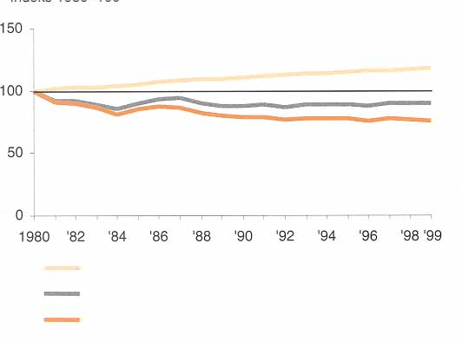

Heated floorspace
Final heat consumption
Specific heat cons/m²

More and Cleaner Biomass
The oil crisis increased dramatically the interest to heat the houses with wood-fired stoves and boilers; later also with straw-fired boilers. In the early 80’ies many households and farms could get subsidises to install boilers for central heating systems fuelled with wood or straw. Also some district heating systems could get subsidies if they changed from oil to wood or straw as fuel. In the 90’ies new activities were introduced. The new activities had an additional aim of introducing equipment for cleaner and more efficient use of biomass. Some of the older biomass boilers were not always efficient or clean enough in the combustion to meet modern demands. A special focus was given to change electric heating to biomass-based heating.

NGOs have been active in many of the activities. Before the national programmes were started, OVE and other NGOs were active in dissemination of information about biomass use, organising visits to people that already were using biomass for heating etc. NGOs were also pushing for the formation of local energy information offices, where people can get free, unbiased information about renewable energy that they can use themselves. Further, the NGOs pushed for start of the national activities to support local use of biomass.

The results of the activities have been:
- gradual increase of biomass use, a doubling in the period 1980-99 to reach 35 PJ/year
- development and introduction of more efficient wood and straw boilers
- introduction of more automatic equipment that does not need the user to attend the boiler more than 1-2 times/week. Many of the new, small systems use wood-pellets made from saw-dust. This development was a response to consumer demand for less time-consuming heating systems, and it guarantees future use, as there is little risk that the users will get tired of biomass use (several users have got tired of the older more manual systems)

The biomass is increasingly used in ovens and boilers in individual houses; in small district heating systems fuelled with wood and straw; as well as in larger biomass-fired cogeneration stations for heat and electricity. For ten years a state subsidy for biomass boilers has been graduated after efficiency, giving the largest subsidies to the most efficient boilers, a measure that has increased considerably the efficiency of the boilers on the Danish market. Biomass use has developed from 15 PJ in 1980 to more than 35 PJ in 2000, now covering 15% of the Danish heat demand.

An example of an automatic boiler for wood chips, capacity 100 – 1000 kW
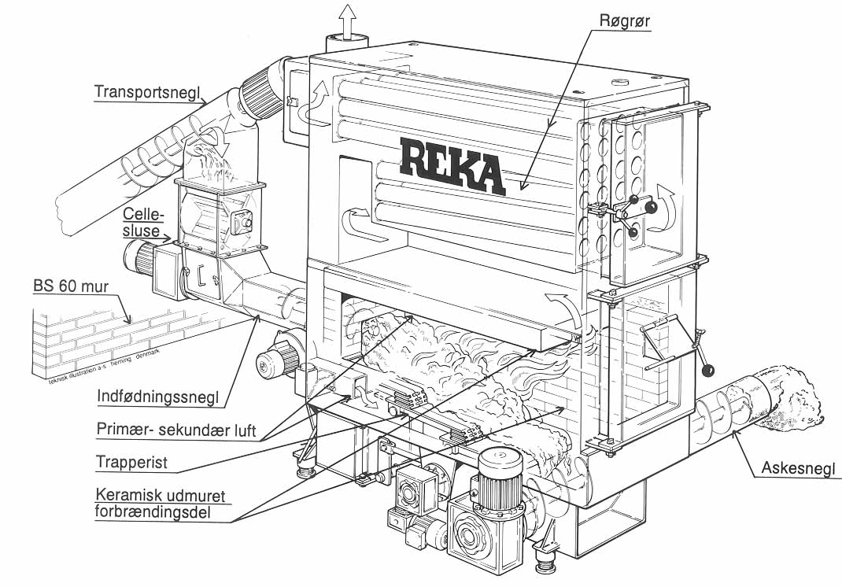
Explanation: Woodchips are fed with a screw-transporter from a magazine behind the wall to the left, fall down through a fire stop to a new screw that feeds the wood-chips into the boiler. The combustion chamber is a the bottom and with ceramic sides and a screw to more the ash. Above the combustion is a flue gas chamber and at the top two sets of flue-gas tubes surrounded by the water that is heated in the boiler.

Cogeneration of Heat and Electricity

The development of cogeneration has been a cornerstone in the Danish energy strategy since 1975. Initially the development focussed on large-scale cogeneration for large district heating systems that supply heat to all larger towns, based on coal-fired cogeneration stations. OVE, other NGOs, and independent specialists recommended a focus on smaller cogeneration systems, fuelled with natural gas and renewable energy. These local solutions were the focus of the cogeneration development in the ‘90’ies.

The measures used were:
- Heat planning: all denser parts of towns are either heated with district heating or with gas
- Energy tax refund: natural gas fired cogeneration got a payment 0.10 DKK/kWh (1.2 UScent/kWh) from the revenue of the Danish energy tax.
- Loan guarantees: municipalities gives guarantees for investments, resulting in low interest rates
- involvement of existing district heating companies (owned by consumer co-operatives and by municipalities), and of newly formed consumer co-operatives that established new, small district heating systems in smaller towns and villages.
- Involvement of industry that has established industrial cogeneration

The result is that more than 50% of the Danish electricity production and more than 40% of space heating is made as cogeneration (80 % of district heating is from cogeneration, district heating supplies over 50% of the space heating). The use of cogeneration has almost tripled since 1980.

Development of Danish District Heating 1980-99

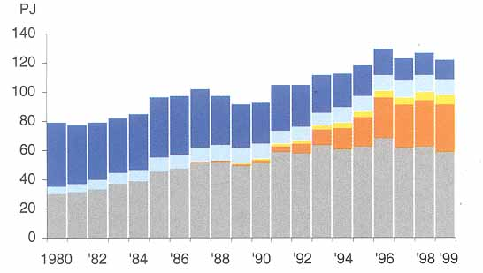
Heating stations
Private produc.
Private cogeneration

Decentralised cogeneration

Central cogeneration

Windpower

While Denmark have had long tradition for windpower in the past and 30,000 windturbines were in operation in 1930, no electricity producing windturbines were working at the time of the oil crisis in 1973. Soon after the first modern windturbines appeared, produced by blacksmith with help of many technically talented persons including professional engineers, and based of principles of earlier windturbines. In 1975 several windturbine companies were active. In 1976 an organisation of windturbine owners was formed (Danish Windturbine Association) to protect the rights of windturbine users. The parallel development of manufacturers and user-groups raised the quality and increased the production volume of the emerging windturbine sector. OVE played a crucial role in this process by organising open meetings for people involved in windturbine development. At these meetings, ideas were discussed in open dialogues, also about technical details and without much secrecy. Together the involved companies and inventors developed the technology faster and better than they could have done individually.

In parallel to the development in the windturbine companies, groups close to OVE developed freely available standard designs of windturbines that individual blacksmith and metal manufacturers could use to produce their own windturbines. One of these groups developed into the Danish Folkecenter for Renewable Energy, now an independent center for development of renewable energy.

While the state established a good test station for windturbines, most state support in the first years went to a utility-lead initiative to develop large windturbines, an initiative that gave some interesting scientific results, but did not manage to develop competitive and reliable windturbines.

An important state-supported project was development of a wind atlas that made it easy to forecast performance of windturbines at sites all over Denmark. From 1980-89, state support was also used to subsidise investments in private windturbines.
In 1980 several companies had serial production of windturbines of the 55 kW class, that were more cost-effective than the cheaper, smaller turbines. These turbines were too large for most consumers, and in response to that OVE and local groups developed the concept of windturbine cooperatives, where several consumers invest in a windturbine together, place it at a good location and feed all the power from it into the grid. In this way it is possible to share a windturbine without making direct electric lines from the windturbine to each owner. Gradually rules were introduced, so that each member of the cooperative could only own shares in proportion to his/her electricity consumption and that the price received for the electricity from the windturbine equalled 85% of the consumer price of electricity. Today most Danish windturbines are owned by these consumer co-operatives.
While Denmark had had a remarkable windpower development in the 80’s, the development in the 90’s was tenfold stronger. In 2000 windpower’s share of the Danish electricity production was 13%.

The reason for the strong development was a combination of:
- Fixed price for electricity from windpower
- National planning for windturbines, where each municipality had to allocate sites for windturbines.
- Regulation of connection fees for grid-connection of windturbines: the power companies are obliged to charge a cost-price for the connection to the nearest grid-point, and to pay eventual grid- reinforcement costs for connection of windturbines
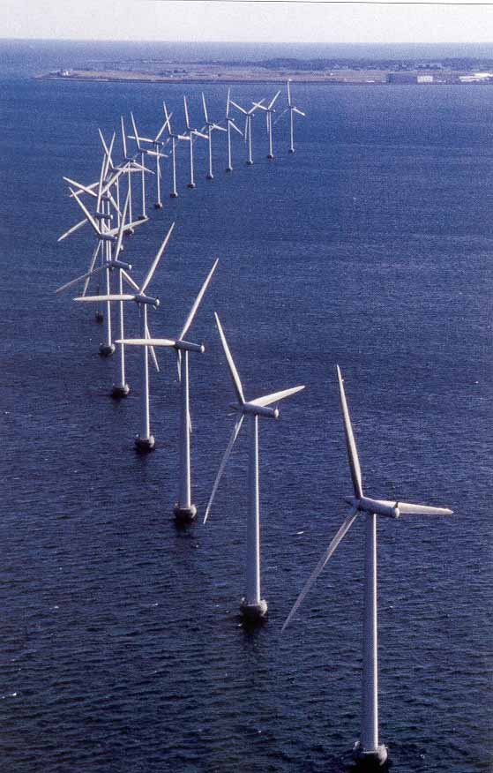
- The decreasing price of windturbines, caused by the technical development and the increasing market.

Middelgrunden:

The latest and the largest windpower co-operative in Denmark where more than 7000 members own half of this 40 MW off-shore windpark outside the Copenhagen harbour. The other half is owned by the utilities. It was inaugurated in May 2001.

25 YEARS DEVELOPMENT IN DENMARK, - THE BACKGROUND FOR DANISH SUSTAINABLE ENERGY ACHIEVEMENTS

At the economic boom in the 60’ies the energy efficiency of the Danish society was quite low. The economic growth of that decade lead to a large growth in the energy consumption, and increasing reliance on imported oil. This dependence was felt hard during the oil crisis in 1973, when oil-prices shut up and the supply was limited. This crisis raised the Danish awareness of the need to save energy and to find alternative energy resources.

One of the first responses to this energy crises was large heat saving programs, in particular in the period 1974-84, but with some activities still continuing.

Soon followed a more comprehensive energy plan, combining energy conservation with change from oil to coal, large-scale cogeneration and nuclear power. This national plan almost excluded renewable energy and local solutions such as local cogeneration of heat and electricity. The response from many concerned citizens and some scientists was to question the nuclear power plans. In 1974 was formed a national NGO against nuclear power (OOA) and in 1975 was formed the Danish Organisation for Renewable Energy (OVE). There was a strong public debate concerning nuclear power and other energy questions. The debate lead to a gradual change in public opinion to be more critical towards nuclear power. In parallel to this, pressure from OVE as well as recommendations from independent scientists lead to state support for development of renewable energy.

In 1981, a new national energy plan was adopted, this time with focus on introduction of natural gas in Denmark and with more scenarios respectively with and without nuclear power. The nuclear power proposals in the plan from 1975 was still under discussion and it was foreseen that there would be a national referendum about the issue before any construction of nuclear power in Denmark could begin. In an alternative energy plan from 1983, made by independent researchers from Danish universities, detailed analysis showed that energy efficiency, renewable energy and local cogeneration could give a cost-effective energy system with minimal use of fossil fuel and no nuclear power.

In 1985 it was clear that neither the Parliament nor the majority of the public wanted nuclear power. As a consequence of this, the parliament decided to remove nuclear power from Danish energy planning without a referendum. This decision is still in force, and a recent poll (May 2001) shows that 86% of the Danish voters are now against nuclear power.

The next chapter in the Danish energy planning starts with the Brundtland report “Our common future” from 1988 and the following decision by the parliament to make sustainable energy plans for the most important sectors. The Danish sustainable energy plan “Energy 2000” was ready in 1990, proposing increased energy efficiency, local cogeneration and more renewable energy. The goal of 20% CO2 reduction by 2005 from 1988 and introduction of CO₂ taxes were parts of the new plan.

The “Energy2000” was followed by a new energy action plan, “Energy21”, from 1996. It marked a continuation of the activities for a sustainable energy system and set with new targets, including indicative targets of 50% CO₂ emission reduction 1990-2030 (weather adjusted figures) and of having 35% renewable energy in the Danish energy mix by 2030 ( from 5% in 1990).

In the following is a number of successful examples of large-scale implementation of energy efficiency and renewable energy in various Danish sectors. Not all sectors shown such successes, e.g. in the transport sector sustainable energy plans have failed.

NGOs have been important to catalyse the development of sustainable energy in Denmark. They organise local users, inform about the possibilities, make campaigns, provide feedback to the state about problems in the development, etc.

Future Plans and Goals
The Danish plans are to continue development of renewable energy and energy efficiency to reduce CO2 emmissions without using nuclear power. Denmark has made a commitment to reduce CO2 emmissions 21% from 1990 to 2010, now a part of the EU burden sharing to reach the Kyoto goals. For the long-term, Denmark has set a target of 50% CO2 reduction 1990-2030. Increase in renewable energy to cover 35% of primary energy supply in 2030 will be an important part of this.
From the Danish NGOs, the vision is to go beyond these official targets and cover 100% of Danish energy demand with renewable energy, within 30-50 years. Past development shows that a rapid transition is possible in energy demand and supply. Examples of this are introduction of heat conservation in the 70’s and early 80’s as well as installation of with windturbines and local cogeneration in the 90’s. With milar rapid developments in the future, the NGO visions could become reality.

The heat conservation activities have involved almost all house-owners in Denmark. In this way it has been a large-scale public education endeavour, leading to activities of a large part of the population to improve their houses.

Sources:
Figures and graphs from Danish Energy Agency’s Energy Statistics 1999, available from www.ens.dk in Danish and English.

