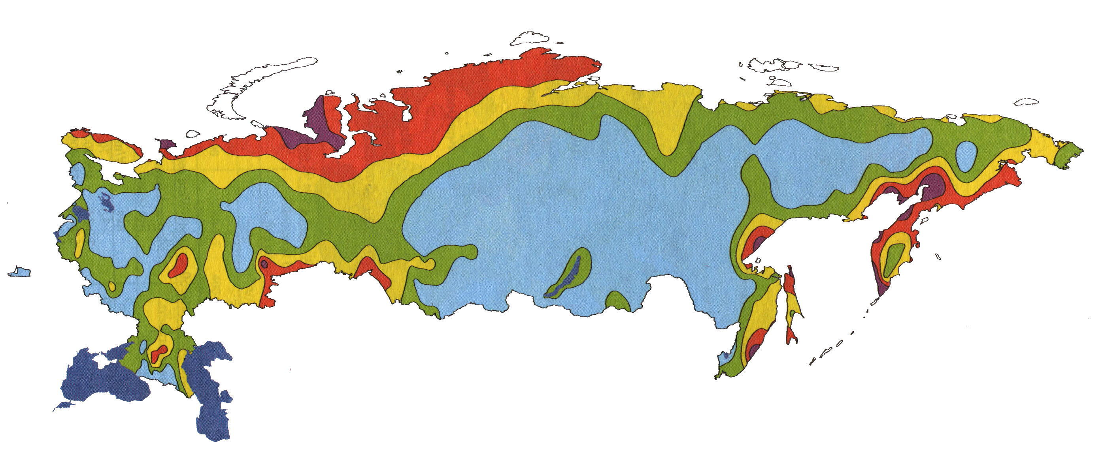
Figure: Wind resources at the hight of 50 m above ground level for five different topographic conditions.
 | Seltered terrain |  | Open terrain |  | Sea coast |  | Open sea |  | Hills and ridges
 | m/s | W/m² | m/s | W/m² | m/s | W/m² | m/s | W/m² | m/s | W/m²
 | >6,0 | >250 | >7,5 | >500 | >8,5 | >700 | >9,0 | >800 | >11,5 | >1800
 | 5,0 – 6,0 | 150 - 250 | 6,5 – 7,5 | 300 - 500 | 7,0 – 8,5 | 400 - 700 | 8,0 – 9,0 | 600 - 800 | 10 – 11,5 | 1200 - 1800
 | 4,5 – 5,0 | 100 - 150 | 5,5 – 6,5 | 200 - 300 | 6,0 – 7,0 | 250 - 400 | 7,0 – 8,0 | 400 – 600 | 8,5 – 10,0 | 700 – 1200
 | 3,5 – 4,5 | 50 - 100 | 4,5 – 5,5 | 100 - 200 | 5,0 – 6,0 | 150 - 250 | 5,5 – 7,0 | 200 - 400 | 7,0 – 8,5 | 400 – 700
 | <3,5 | <50 | <4,5 | <100 | <5,0 | <150 | <5,5 | <200 | <7,0 | <400

