4. Possible Prospects for Wind Energy Developments on Kola Peninsula as the Example for Russia

  - Short geo-economical characteristics

The Kola Peninsula is located in the most northwestern part of Russia between the 66–70° latitude and 28° 30'–41° 30' longitude, bordering on Finland and Norway. The Peninsula is facing the Barents Sea in the north and the White Sea in the south. As the Peninsula is located almost entirely above the Arctic Circle, the climate is generally harsh and snows cover the ground for most of the year. The Gulf Stream, however, keeps the Barents Sea ice-free throughout winter and prevents permafrost. The average temperature varies between –13°C in January and +14°C in July. Most of the peninsula is taiga or forest-tundra and inland there are several mountainous areas, with the highest peaks (Chasnachorr 1191 m a.s.l.) in the Khibiny massive.

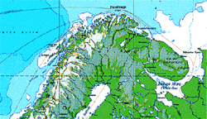
Figure 4.1. A map of the North-Calotte area of northern Europe showing the geography of the Kola Peninsula.

The state of the environment on the Peninsula is in many respects alarming. At the same time, however, it holds some unique natural environments in the world, like virgin wilderness and unspoiled tundra landscapes, and parts of the peninsula are protected. Industrial emissions pollute the inland waters and the sea. Water pollution has reduced fish stocks and fresh-water purification does function properly.

The disintegration of the Soviet Union has led to rapid changes in the Russian economy, both on macro and micro level. During the first years of the 1990's, inflation was extreme but has somewhat settled for the time being. Price levels and salaries are, however, still low compared to Western Europe. The outdated present technology and infrastructure, high maintenance need and poor investment possibilities all affect any economic activity in as well the Murmansk region as elsewhere in Russia.
The Kola Peninsula always held an important strategic and economic position. In this century, the importance of the region was accentuated by the foundation in 1916 of the present-day capital Murmansk on the banks of the Fjord of Kola and the ice-free Fjord of Kola harbour that operates in connection with the city. Since then activities have been going on especially in the field of mining and metallurgy. More than 40 minerals are found in the region and 30 of them are quarried. Nickel, iron, apatit, nephelin, copper, cobalt, aluminium and wolfram are among the minerals being exploited industrially.
Recently another oil and gas fields have been found under the seabed of the Barents Sea. The Shtockmonovskoye gas field is considered to be the largest offshore deposit of natural gas in the world. Other important economic activities are timbering, fishing and fish-industry.
The trade balance of the Murmansk region is considerably positive, over 350 million US$ in 1993. Exports are mainly to the southern parts of the Russian Federation. Main export products are mineral and metal raw materials, fish products and energy whereas imports consist of equipment and machinery. There are still significant technical obstacles in foreign trade. Export and import quotas and licenses regulate the exports of products that are essential to the functioning of the economy. In some cases, the form of ownership of enterprises can ease the need for export licenses.
During the cold war, the Soviet Union spent astronomical sums on the military bases of the Kola Peninsula and the military has a great influence in the region, both politically and economically. This will affect the freedom of operation of foreign enterprises and specialists in development of the region, but could also be a support in mastering of new technology.

4.2 Structure and situation of the energy sector

The total energy consumption on the Kola Peninsula has during the 90's been 13–17 TWh/year and during 1995 consumption rose for the first time since 1989, but after 1995 the consumption continue to decrease. The total generating capacity is 3.66 GW, of which 1.6 GW is hydro and 1.8 GW nuclear power. The mostly public owned utility company AO Kolenergo handles all sales and distribution and all production, except electricity of the nuclear power plant from which Kolenergo, however, buys the whole production. 68 % of power and 33 % of heat production is used by the industry and respectively 11 and 52 % by communal user. Energy prices, as in Russia in general, have been rising steadily for the past years but are still remarkably low, compared to other industrialised countries.
Several settlements, fishing villages, meteorological, radio link, border stations and alike are located far from the electrical grid. Most of them are for the moment powered mainly by diesel generator sets. However, as fuel is getting increasingly scarce wind energy could make a substantial contribution to the power supply in these communities. Total possible installed capacity of the small insulated WECs for Murmansk region could reach 5 MW, that will be a little more, then 0,1 % of total power system installed capacity. The figure, mentioned above reflects only the part of the total demand in electric energy of all insulated consumers, but the part, which is ensured by wind energy resources.
This figure is similar for the rest of Russian regions. In spite of in Central and Southern areas of Russia population of agricultural villages bigger, then in the North, in these areas the share of centralized electricity supply is equal or higher then in the North, and the percent of availability of the wind power resources of high quality are lower, then in the North.

4.3 Kola Peninsula's wind power resources

The wind energy potential on the Kola Peninsula is known, by research done at the Kola Science Centre, to be extremely good, comparable to the best regions in Europe [3–7]. The main results have also been presented at international conferences [8–11]. The Kola Science Centre has also been operating a test field for smaller wind turbines in Dalnie Zelentsy, on the north coast [12].
The activity of the Kola Science Centre has also affected the political attitude. Wind energy is also on the political level seen as an option, mainly to power remote settlements, that are not yet grid connected.
The Murmansk Regional Hydrometeorological service has 35 meteorological and synoptic stations on the Kola Peninsula, of which 10 report to WMO. The oldest measurements date back to 1861.
Based on collected data from these stations, KSC-IEN produced the wind map shown in Figure 4.1. The map is based on measurements in the period from 1966–1985. The highest mean wind speeds exceed even 10 m/s on the northern coast. A special feature is that the wind is heavily directional, especially during winter. On a whole year basis, southwest winds count for 54 % of the time [6].
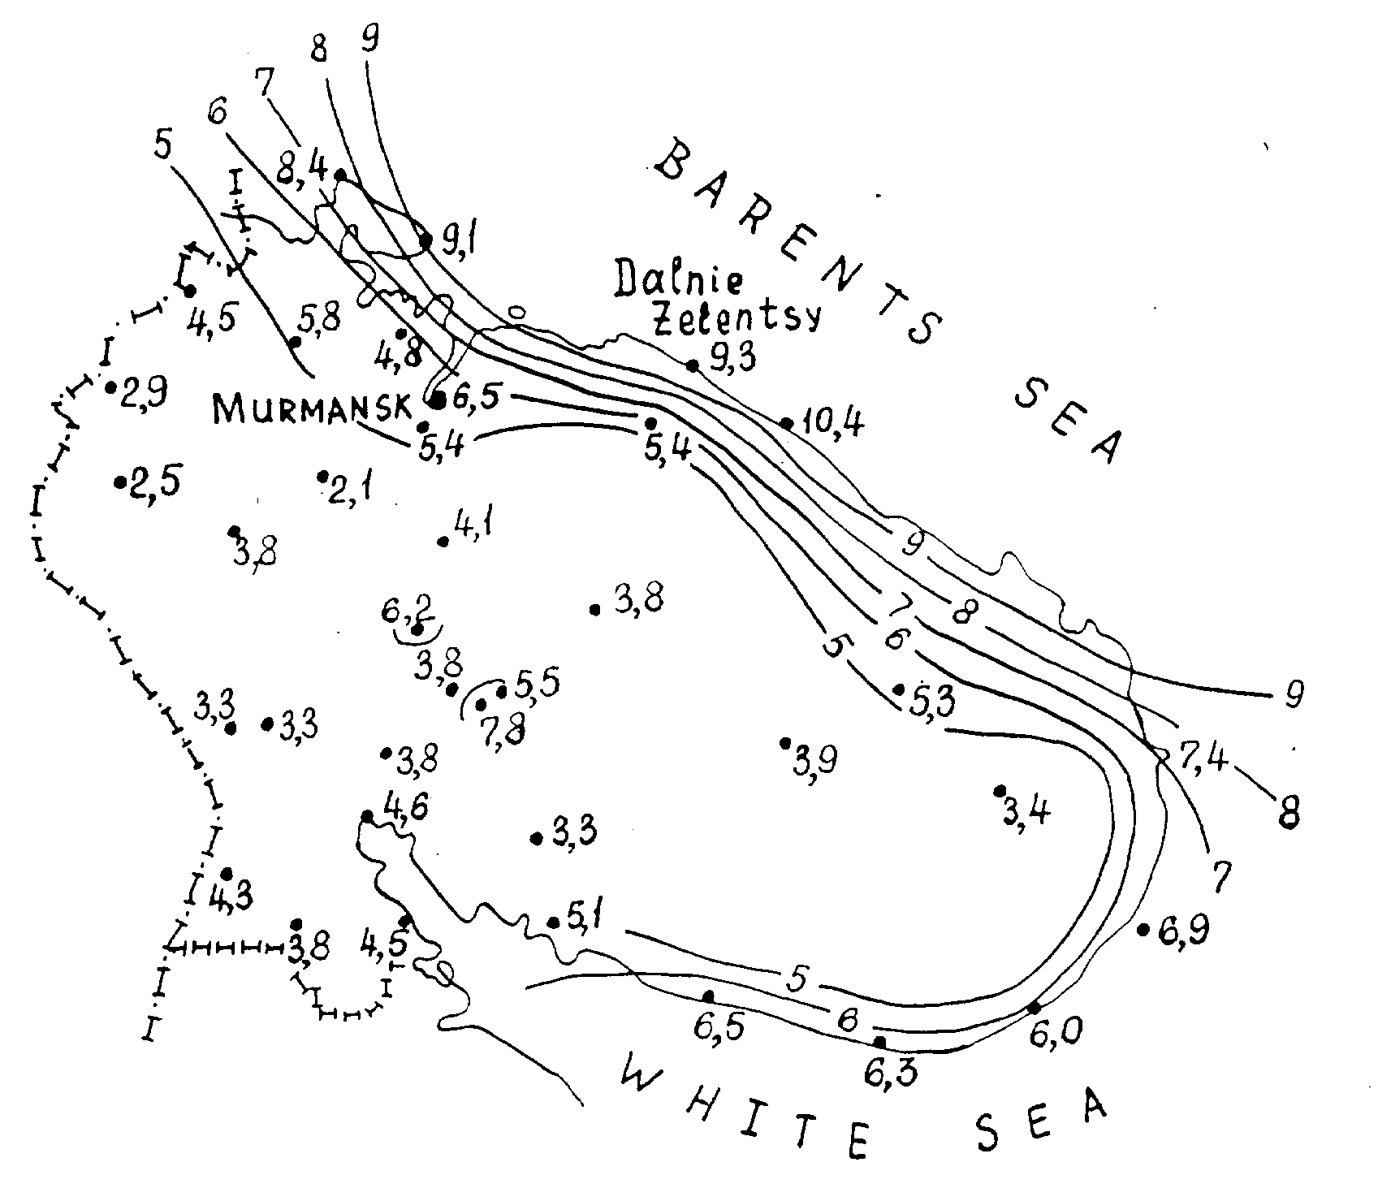

Figure 4.2. A presentation of the wind resources over the Kola Peninsula [6], based on long-term measurements from meteorological stations (locations and mean wind speeds are shown in the figure).
Availability of prevailing wind directions permits to place big wind parks with lower expenses on landscape. The maximum of wind speed takes place during the cold time of a year and coincides with seasonal peak of heat and electricity consumption. Typically, that winter maximum of wind is here in counter-phase of the river water discharge. In coastal districts of Kola Peninsula variation of annual average wind speed from year to year is small and characterises by variation factor in the limits of 5-8%. In the same time variation factor of Kola Peninsula river discharge makes about 15-20%. That is mean that in multi-year regime wind is more stable, then river discharge.
In the table 4.1 are shown the results of calculations of technical wind energy resources of Kola Peninsula.
Table 4.1.

The wind resources of Kola Peninsula in the ground surface layer up to 100m.

 | Zones |  |  |  |  | Total
 | 1 | 2 | 3 | 4 | 5 | Total
Annual average wind speed in the zone
At height 10 m, m/s | 8,5 | 7,5 | 6,5 | 5,5 | 4,5
At height 70 m, m/s | 10,7 | 9,6 | 8,6 | 7,5 | 6,5
Specific wind energy MW h/(m²/year)
At height 10 m | 7,5 | 5,2 | 3,4 | 2,4 | 1,4
At height 70 m | 14,1 | 10,7 | 7,8 | 5,2 | 3,4
Annual average specific wind power,
At height 10 m, kW/m² | 0,86 | 0,59 | 0,39 | 0,27 | 0,16
At height 70 m, kW/m² | 1,61 | 1,22 | 0,89 | 0,59 | 0,39
Rated wind speed, m/s
At height 10 m | 13,5 | 12,3 | 10,4 | 8,5 | 7,6
At height 70 m | 17,0 | 15,7 | 13,8 | 11,6 | 11,0
Capacity of WEC on each 1 km² of territory, MW | 9,1 | 7,2 | 4,9 | 2,9 | 1,9
Annual WEC production per 1 km², mln. kWh | 27,3 | 21,6 | 14,7 | 8,7 | 5,7
Annual load factor, hours | 3000 | 3000 | 3000 | 3000 | 3000
Square of zone, thous.km² | 2,2 | 3,0 | 3,5 | 10,0 | 15,0 | 33,7
Capacity of WECs in zone, thous. MW | 20 | 22 | 17 | 29 | 29 | 117
Technical wind power resources, billn. kWh. | 60 | 65 | 51 | 87 | 86 | 349

The calculations been made according to the zones, shown in Fig. 4.2. In first zone annual average wind speed is higher 8 m/s, in the second speed is between 7-8m/s, in third - 6-7m/s, in fours – 5-6 m/s, in fifth – 4-5m/s. From table 4.2 it’s clear, that if in the zones, mentioned above, to built continuous massive of WECs, located at the distance in 10 diameters of rotor one from another, then total installed capacity of WECs makes more then 100,000 MW, and annual electricity production – more then 350 bill. kWh, that is in about 20 times higher, then today’s demands of energy system.

