Polish Ecological Club Upper Silesian Branch
Institute of Thermal Technology
Silesian University of Technology
Polish Foundation of Energy Efficiency
INFORSE- Europe

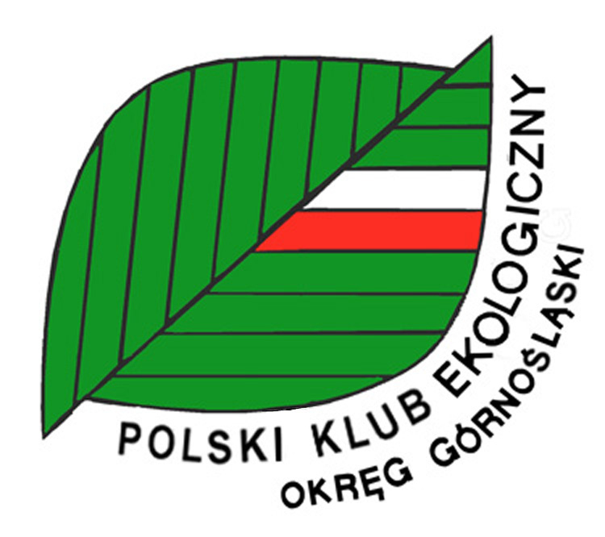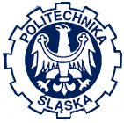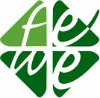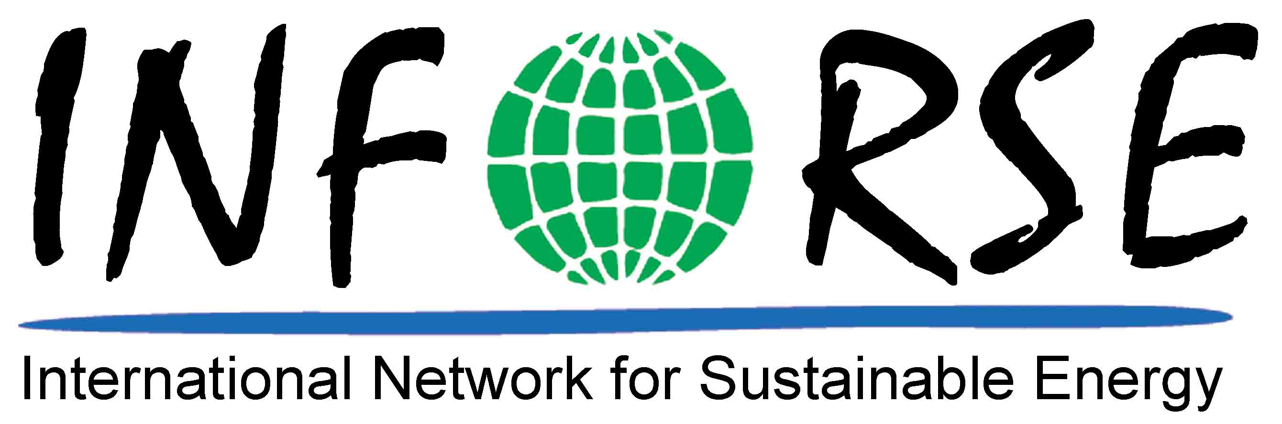

Are honored to invite you to participate in the technical conference dedicated to

CLIMATE PROTECTION

Environmental Protection & Sustainable Energy Management

Transposition of EU Regulations Connected with Environmental Protection

Which will take place in

Katowice, 14th December 2007.

Localization:
Upper Silesian Culture Centre
Plac Sejmu Śląskiego 2
40 – 032 Katowice

The conference is granted from resources:


Wojewódzkiego Funduszu Ochrony INFORSE – Europe
Środowiska i Gospodarki Wodnej w Katowicach EC DG ENV Civil Society Support

POLISH ECOLOGICAL CLUB UPPER SILESIAN BRANCH
ul. Jagiellońska 4/7, 40-032 Katowice
tel. (032) 793 94 83; e-mail: pkeog@poczta.onet.pl
www.polskiklubekologiczny.org

Under auspices of:

Chancellor of Silesian Province – Janusz Moszyński
President of Silesian University of Technology – Wojciech Zieliński

Committee:

Dr inż. Krystyna Kubica | Przewodniczący – PKE OG Katowice,
Dr hab. inż. Andrzej Szlęk | Politechnika Śląska Gliwice
Dr inż. Sławomir Pasierb | FEWE Katowice
Gunnar Boye Olesen | INFORSE-Europe
Mgr Anna Bogusz | Polski Klub Ekologiczny OG Katowice

PRELIMINARY PROGRAMME

9:00 – 9:30 | Participant registration
9:30 – 9:40 | Opening of the conference
9:40 – 10:10 | Paweł Kojs University of Silesia The CO₂ emission in Poland as an imminent danger for climate; Undertaken counteractions
10:10 – 10:40 | Jamrocha Jerzy, Voivodship Inspectorate of Environmental Protection in Katowice. Air quality conditions; CO₂ emission at the Voivodship of Silesia
10:40 – 11:10 | Pasierb Sławomir, Polish Fundation of Energy Efficiency Primary Energy Saving by the EE directives and Polish implementation strategy
11:10 – 11:40 | Wiśniewski Grzegorz, Institute of Renewable Energy Renewable Energy Sources in Poland: The EU integrated climate and energy policy in aspect of national conditionary
11:40 – 12:10 | Gunnar Boye Olesen, INFORSE-Europe  Directives implementation and climate protection in the EU
12:10 – 12:40 | Coffee break
12:40 – 13:10 | Andrzej Ziębik, Joachim Kozioł Politechnika Śląska, Eco-energy policy of Silesia Province in heating sector and implementation of UE Directive on co-generation
13:10 – 13:40 | Michniowski Zbigniew, Vice President of Bielsko Biała and Chairman of the Board PNEC (PL), Sustainable energy managment at the municipiality; Case study- Bielsko-Biała
13:40 – 14:10 | Marshall Office of the Silesian Voivodship. Structural funds and other financing possibilities for the EU climate and energy policy implementation at the Voivodship of Silesia.
14:10 – 14:30 | Sumary. Discussion

