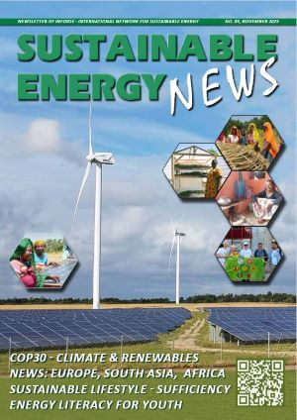
Sustainable Energy News No. 89, November 2025
Newsletter of INFORSE, International Network for Sustainable Energy
https://www.inforse.org/doc/SEN89.pdf
More:
https://www.inforse.org/europe/news-fr.htm and
https://www.inforse.org/s_e_news.php3
EDITORIAL p. 2
Climate Change is Not up for Debate - and Sustainable Energy is Still the Answer
GLOBAL p. 3
- COP30 - Ambition & Just Transition Needed.
- INFORSE at COP30 Exhibition and Side Event.
- Don't Nuke the Climate.
EUROPE p. 4-7
New Projects:
- Energy Literacy for Youth (ELY), New European Cooperation Project on
Creating Participatory Education. Project funded by EU Erasmus Program.
- Sufficiency as Climate Action in Nordic & Baltic Countries and Belarus.
Project funded by the Nordic Council of Ministers.
News:
- INFORSE-Europe at EUSEW 2025.
- Decarbonising Heating and Cooling in the EU, Report on NECP Analysis.
- Debating and Analysing EU Climate Plans and Targets 2030 – 2040.
- INFORSE-Europe Board Visiting Energy Communities in Hungary.
News from INFORSE-Europe members:
- Denmark: Nordic Folkecenter for Renewable Energy Need Your Support
- Wales UK: CAT, Centre for Alternative Technology
- Germany: Artefact - Award, Climate Wall, Tiny House
- Hungary: Energiaklub - Court Rule for New Climate Law in Hungary - Manifesto of 34 CSO
SOUTH ASIA p 8-9
News from INFORSE-South Asia members:
- India: AIWC All India Women Conference - Solar Energy to Ensure Women’s Safety
- Bangladesh: CCDB Climate Center
- In memory of Raymond Myles - INFORSE South Asia Coordinator
AFRICA p 10
News from INFORSE-Africa members:
- Uganda: JEEP - Joint Energy and Environment Projects, Folkecenter
- Mali: Mali Folkecenter Nyetaa (MFC Nyetaa)
- Kenya: SUSWATCH Kenya's Path to a Renewable Future
ONLINE DATABASES: p. 11
- Catalogues of Local Climate Solutions in East Africa, and South Asia Eco Village Development.
- Catalogue: What You Can Do to Save Energy and Use Renewables - English, Ukrainian and Russian.
- DIERET Online Education material NOW also in Ukrainian
BACK PAGE p. 12
INFORSE's is a world-wide network of 145 non-governmental organizations in 60 countries.
INFORSE Web site – Social Media
https://www.inforse.org/
https://www.facebook.com/INFORSE - https://www.linkedin.com/company/inforse
https://bsky.app/profile/inforse.bsky.social -

