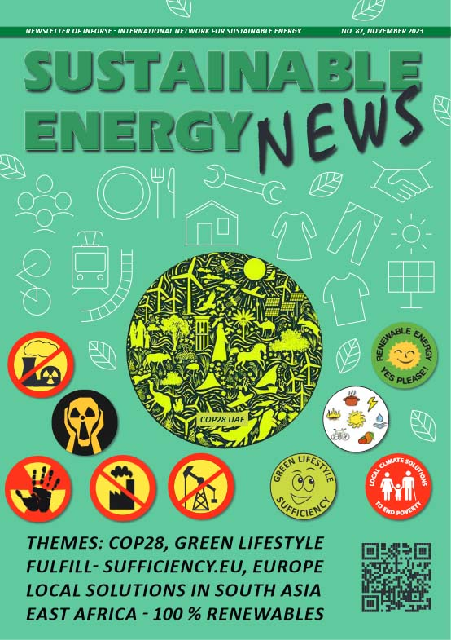
Sustainable Energy News No. 87, November 2023
Newsletter of INFORSE, International Network for Sustainable Energy
https://www.inforse.org/doc/SEN87.pdf
More:
http://www.inforse.org/europe/news-fr.htm and
http://www.inforse.org/s_e_news.php3

EDITORIAL p. 2
Climate Stability Needs More Actions - Also More Soft Climate Policies

GLOBAL p. 3
- We Need Stronger Global Cooperation to Manage the Climate Crisis
- INFORSE at COP28
THEME: FULFILL -
SUFFICIENCY.EU pp. 4-7
- Sufficiency in Climate Policies - European Projects Show Where & How
- CLEVER Scenario with Sufficiency p. 7

South Asia pp. 8-9
Eco-Village Development in South Asia NGO Cooperation Projects' Results in Nepal Bangladesh, India, Sri Lanka;
Database of Local Solutions; Publications in English and national languages.

Europe pp. 10
News from INFORSE-Europe
- Better Green Deals with Civil Society Proposals
- Shifting Subsidies away from Fossil Boilers Can Decarbonise EU Heating
- Ecodesign for Energy Efficiency, Cleaner Air and Circular Economy
- EU Energy Poverty Advisory Hub in Hungary
- Database and DIERET also in Ukrainian

East Africa p. 11
- Local Climate Actions Continues in Uganda
- Publications: Catalogue of Local Solutions On/Offline Brochure in 5 languages;
100% RE Kenya & Uganda

BACK PAGE p. 12
- INFORSE's Synergy Across Continents Publication
- INFORSE description
- INFORSE at COP28

